Hybrid Creatures: Mapping the emerging shape of art therapy education in Australia, including reflections on New Zealand and Singapore.

By Dr Jill Westwood
University of Western Sydney & Goldsmiths, University of London

Abstract
This article summarises key findings of a PhD research project that provides the first organised view of art therapy education in Australia. A bricolage of methods were used to gather and analyse information from several sources: literature; institutions/programmes; and key participants, including the author. It provides a map of art therapy education in Australia, a genealogy of its educators and captures prevailing views and trends across the country and countries of influence, namely USA and UK. Consideration of these findings is given to art therapy education in Australia and to the wider region, specifically New Zealand and Singapore.

Introduction

I love a sunburnt country,
A land of sweeping plains,
Of ragged mountain ranges,
Of droughts and flooding rains.
I love her far horizons,
I love her jewel-sea,
Her beauty and her terror-
The wide brown land for me!

The words of this iconic poem by Dorothy Mackellar echo with the psyche of Australia and the essence of this research project; to map the arduous and soulful work of art therapy education in Australia. The project evolved from my immersion in the field as a migrant art therapy educator to Australia from the UK in 1995, and a desire to be reflexive on this experience. The research questions aimed to discover the field of art therapy education in Australia: to find out what theories and practices were taught; and where the theoretical influences were coming from, in order to develop understanding of this emerging field. The aim was to contribute knowledge to support the development of art therapy education and the profession in Australia, and ultimately to benefit the health and wellbeing of people and societies.
Positioned as qualitative research a bricolage of methods (McLeod, 2006) were used to gather and analyse information from several sources (literature; institutional sources; and key educators, including myself). This also included investigating other places and educators in the world shown to be influential (USA and UK). In terms of epistemology the project was located in the paradigm of personal knowledge and subjectivity. As such this emphasised the importance of personal experience and interpretation and involved capturing the voices and experiences of the educators themselves. For a full description of the project see Westwood (2010). This article is intended to present some key aspects of the mapping process, its broad discoveries and to say something of the meanings of the project and how this maybe relevant for the field and the region.

Literature review

To locate the project within the field of knowledge a literature review was undertaken, this showed, how art therapy education is closely linked with the development of the art therapy profession across the English speaking world and that a relatively small number of art therapy educators had made contributions through research and publication on the topic. There were two significant books devoted to the topic both from the USA (McNiff, 1986; Moon, 2003). McNiff’s book presented the most comprehensive study promoting a multi modal integrative position. Moon’s book presented a more personal account from an existential philosophical position. Within this literature themes were found that could be clustered as: therapy/education tension; relationship to art; and, context: difference/culture/race.
A common tension is described between the therapeutic and educational aspects of art therapy training and the ways this can be worked with and understood (Junge & Asawa, 1994; Waller, 1991, 1992, 1998) amongst others Throughout the literature, there is frequent discussion on the use of experiential methods in training, such as with art therapy groups (Dudley, Gilroy & Skaife, 2000; Franklin et al, 2000; Menahemi, 2006; Skaife & Jones, 2009) and in supervision groups (Brown, Meyerowitz-Katz & Ryde, 2007; Edwards, 1993). Central to this is the use of the self in the teaching and learning process by both students and educators and the tension inherent in this overlap. Discussion of psychodynamic concepts of transference and counter-transference recur in relation to how these aspects are worked with and considered. Linked to this is the significance of having personal therapy while undertaking the training and how this interconnects with the experiential learning. The educator as role model also appears as a significant aspect.
The theme of the student and educator’s relationship to art was also found. Whether the entrants have substantial backgrounds in art or not, how art is positioned in the training programme and how much the artist identity is emphasised through the content of the curriculum (Gilroy, 1992; McNiff, 1986; Moon, 2003; Waller, 1992; Waller & James, 1984).
Context, difference, culture and race also emerged as a theme and several articles considered the importance and significance of working with difference and power in the education process (Brooks, 1998; Holloway, 2009; Linesch, 2005; Skaife, 2007; Ward, 1998). More recently the imperative for the development of research education has been raised (Gerber, 2006; Kapitan 2010).
Various debates such as; the integration of the arts as opposed to the separation of them into distinct disciplines and the movement towards a greater emphasis on the arts and links to universal and sacred dimensions were found (Knill, Levine, & Levine, 2005; McNiff, 1986; Moon, 2003).
Literature from Australia revealed a strong influence of the practices and views from both UK and USA, and the potential synthesis or syncretic relationship of these into something uniquely of the place (Campanelli & Kaplan, 1996; Coulter, 2006; Edwards, 2007; Gilroy, 1998; Gilroy & Hanna, 1998; Henzell, 1997, 2003). The review showed that an investigation into art therapy education in Australia had not been undertaken prior to this research. The nearest other similar research was by Karkou and Sanderson (2006) who provided a substantial map of the field of the arts therapies in the UK. It is from this background of knowledge coupled with my interest in theories and the relational processes of art therapy education that this research arose.

Mapping the terrain: methodology

The research was designed to gather information, then through a process of observation, description and analysis develop knowledge about art therapy education, with focus on the theoretical influences, charting what is present and identifying how this has evolved. The methodology was built upon a set of questions; conducting semi-structured interviews, transcription of the interviews, development of case summaries (institutional profiles), educator profiles and the analysis of these. A case study approach was selected to condense the material on each institution/programme into institutional profiles. These profiles formed the ‘thick description’ that paved the way towards the process of analysis. In terms of procedure art therapy education programmes in Australia were identified; key art therapy educators were invited to participate to gather information on the programmes and the views of the educators. Following this, other art therapy educators named as key influences or who had expert knowledge in either the USA or UK, were selected. These art therapy educators were then invited to participate to gather further information, relevant in tracing the origins of influences from other places, and a previous generation of educators. An investigation and analysis of the relevant literature was conducted; and, an autoethnographic investigation was produced to provide a multi-faceted view of the field.

A bestiary of art therapy education in Australia

Inspired by the spirit of art therapy I focused on arts-based methods throughout the process and made images to explore the topic. I will focus on one image ‘A bestiary of art therapy education in Australia’ (Figure 1) as this embodies an important part of the substance of the research. In order to unfold the content it is relevant to consider the context of Australia; which is a vast, mainly desert, island continent with a relatively small population mostly concentrated around the coastal fringe. Significant European settlement began in 1788 with the establishment of a penal colony by the British. This process of colonisation has also become known as an ‘invasion’ (Reynolds, 2001). This had a devastating impact on the Aboriginal peoples who are considered the oldest continuous living culture in the world. From this penal background it has been suggested that a more custodial and disciplinarian approach was adopted to mental health care compared to other parts of the world (Gilroy & Hanna, 1998; Lewis, 1988). This has led to a system dominated by the medical model which favours cognitive, behavioural and psycho-educational approaches. Psychotherapy and the arts therapies are on the margins and have struggled to become established as legitimate psychological interventions in this context. The Australian National Art Therapy Association (ANATA) was formed in 1987 largely by people who had either trained or gained experience as art therapists in Britain, Canada or the USA. This group endeavoured to integrate different theoretical, clinical and ethical approaches (Coulter, 2006). Since then several surges of development have taken the field forward such as; the inclusion of New Zealand in 2005; a new category of membership including all the arts in 2007; links with Singapore in 2009 and in renaming itself the ‘Australian and New Zealand Arts Therapy Association’ (ANZATA) 2010.

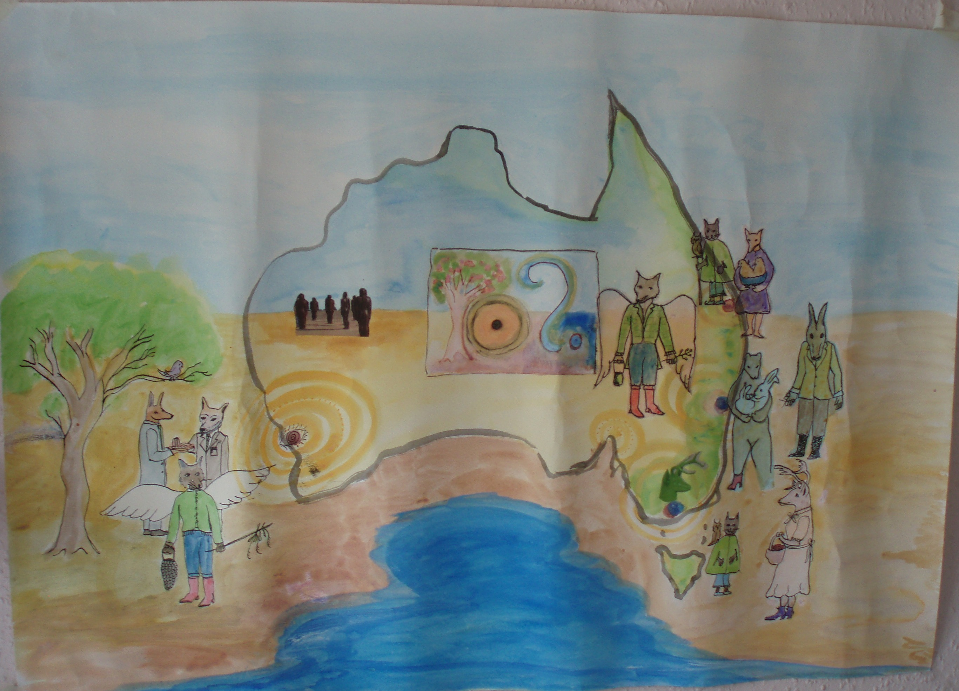
Figure 1

In figure 1 an imaginary family or bestiary of hybrid creatures is pictured on the map of Australia. It was created in response to the material that was gathered from the interviews with the educators in the seven different art therapy training programmes that were found in the field. Table 1 provides an overview of the location of programmes; level of qualification; start of offer and current status as of 2010.

Table 1: Australia art therapy programmes overview in 2010
Institution | Qualification | Start | Closed/  Continuing
Edith Cowan University, Perth, Western Australia  (ECU) | Master of Art Therapy  Precursor: Postgraduate Diploma in Art Therapy (1989-1991) | 1992 | Closed 2007
University of Western Sydney, New South Wales  (UWS) | Master of Art Therapy | 1993 | Continuing
Royal Melbourne Institute of Technology, Victoria  (RMIT) | Master of Creative Arts Therapy | 1996 | Closed 2007
La Trobe University, Melbourne, Victoria  (MIECAT beginnings) | Master of Art Therapy  Master of Counselling:  The Arts in Therapy | 1998  1991 | Continuing  Closed 1996
University of Queensland, Brisbane, Queensland  (UQ) | Master of Mental Health – Art Therapy | 2004 | Continuing
MIECAT (Melbourne Institute of Experiential Creative Arts Therapies), Victoria | Master of Arts by Supervision (Experiential Creative Arts Therapies) | 1997  Accredited 1999 | Continuing
IKON INSTITUTE: Locations in Perth, Western Australia, Adelaide, South Australia, Melbourne, Victoria, Sydney, New South Wales, Brisbane, Queensland | Diploma in Transpersonal Art Therapy | 1988 | Continuing

The process of interviewing a range of art therapy educators of different backgrounds and philosophical views produced new connections and understanding for me. It stimulated a desire to link, and be in relationship with all the participants, rather than rivalry or opposition, which is a common process of groups. I experienced the richness of the variety and passion of the educators and programmes as enhancing and fascinating and I wanted the image to hold something of this varied and relational quality.
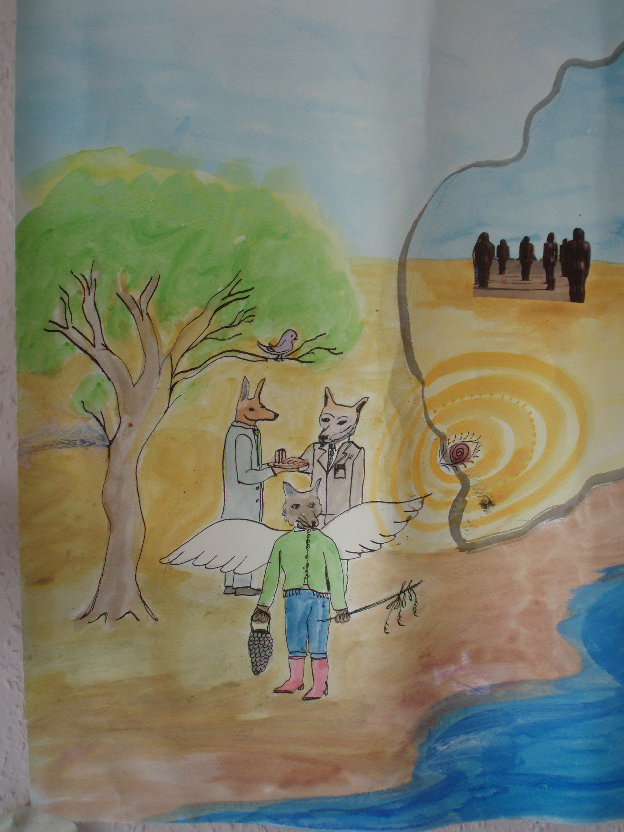
Figure 2

On the Western side of Australia (Figure 2), the group of creatures featured hold qualities and dynamics of the two programmes that have come from this region, Edith Cowan University (kangaroo, dingo, bird) and Ikon Institute (winged fox-coyote). The ECU programme began in 1989 and revealed elements of conflict concerning different cultural and theoretical views. A clash between different educator’s views from the UK and USA were found. These differences could be summarised as an ‘experiential’ dynamic approach (UK) versus a ‘methods’ approach (USA). The experiential / dynamic view favoured an object relations approach and an emphasis on art. The ‘methods’ approach prioritised the development of research and a more didactic view related to medical sciences and directive approaches. Different views of art therapy can be linked to the different systems of health care found in UK (social model) and the USA (private insurance model). These struggles were significant and echoed the developmental process often found in the emergence of new professions. This conflict was lived through but eventually due to institutional, managerial and economic changes the programme closed in 2007.
In 2010 Ikon (winged fox-coyote) was the only provider of art therapy education remaining in WA. This figure reflects the transpersonal and psycho-spiritual energies that began in this place. He is pictured standing apart and independent. Ikon emerged concurrently to ECU and arose from the private sector, at diploma level, through projects with Indigenous Australians in Western Australia. The transpersonal view calls upon spiritual traditions and their healing practices and includes Indigenous perspectives. This was in contrast to the main stream medical/health paradigm where the university based programmes were seeking to gain ground. Therefore significant differences concerning approaches, levels of training and outcomes between Ikon and ECU (and other university based programmes) were found. The fox-coyote also has a strong presence elsewhere, as Ikon also offered art therapy training in other states (SA, VIC, NSW and QLD).
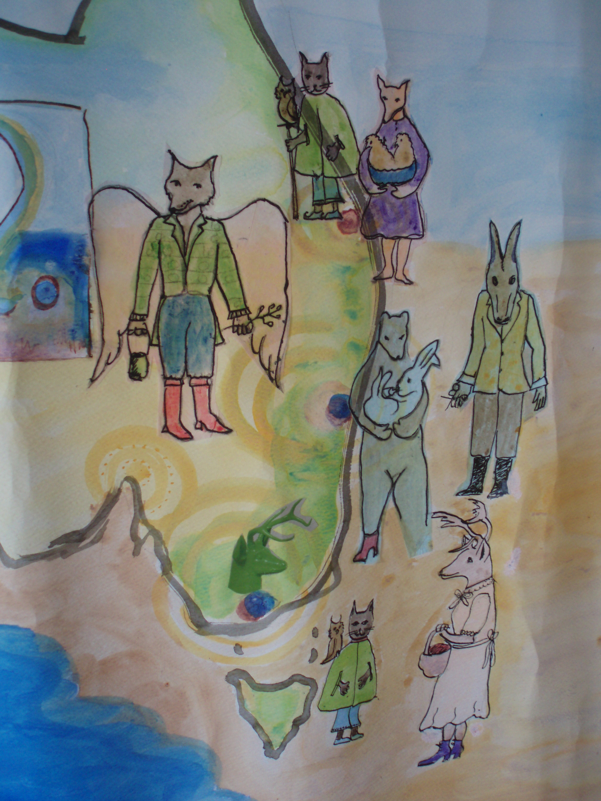
Figure 3

On the Eastern side there are many more creatures. The programme at the University of Western Sydney began in 1993 and is symbolised by the family group of the bear, rabbit and donkey. The donkey holds a pair of scissors and has ambiguous qualities related to the dynamics within the university system, of whether he will be helpful and protective or snip away and disturb the mother and baby. Here the importance and position of art within the education process and institutional allies were highlighted. The theoretical flavour of UWS was summarised as moving from a psychodynamic to an integrative-narrative, post structural perspective. This shift was influenced by ongoing institutional, managerial and economic changes alongside different educator’s backgrounds and preferences. This story revealed turbulent beginnings with early educator influences from UK, Canada and USA and similar issues found at ECU. This was followed by a phase of consolidation with myself seeking to find a way to marry and adapt my background view (UK) with the different views I encountered. Since 2008 an Australian (UWS) trained educator has taken the leadership and the programme has become closely linked with a Master of Social Science through shared modules. This intercultural mix has been at the heart of several programmes. Overall the UWS programme was described as “surviving through art”. This was due to art-based learning methods being integrated into the education process, which was percieved as enabling it to adapt and survive in the face of changes. This emphasis on art arose through the staff team who began to collaborate and exhibit together as artists and from this a guiding metaphor developed, of the practice and training as “installation and performance art” (Linnell, Perry, Pretorius & Westwood, 2007, 2011).

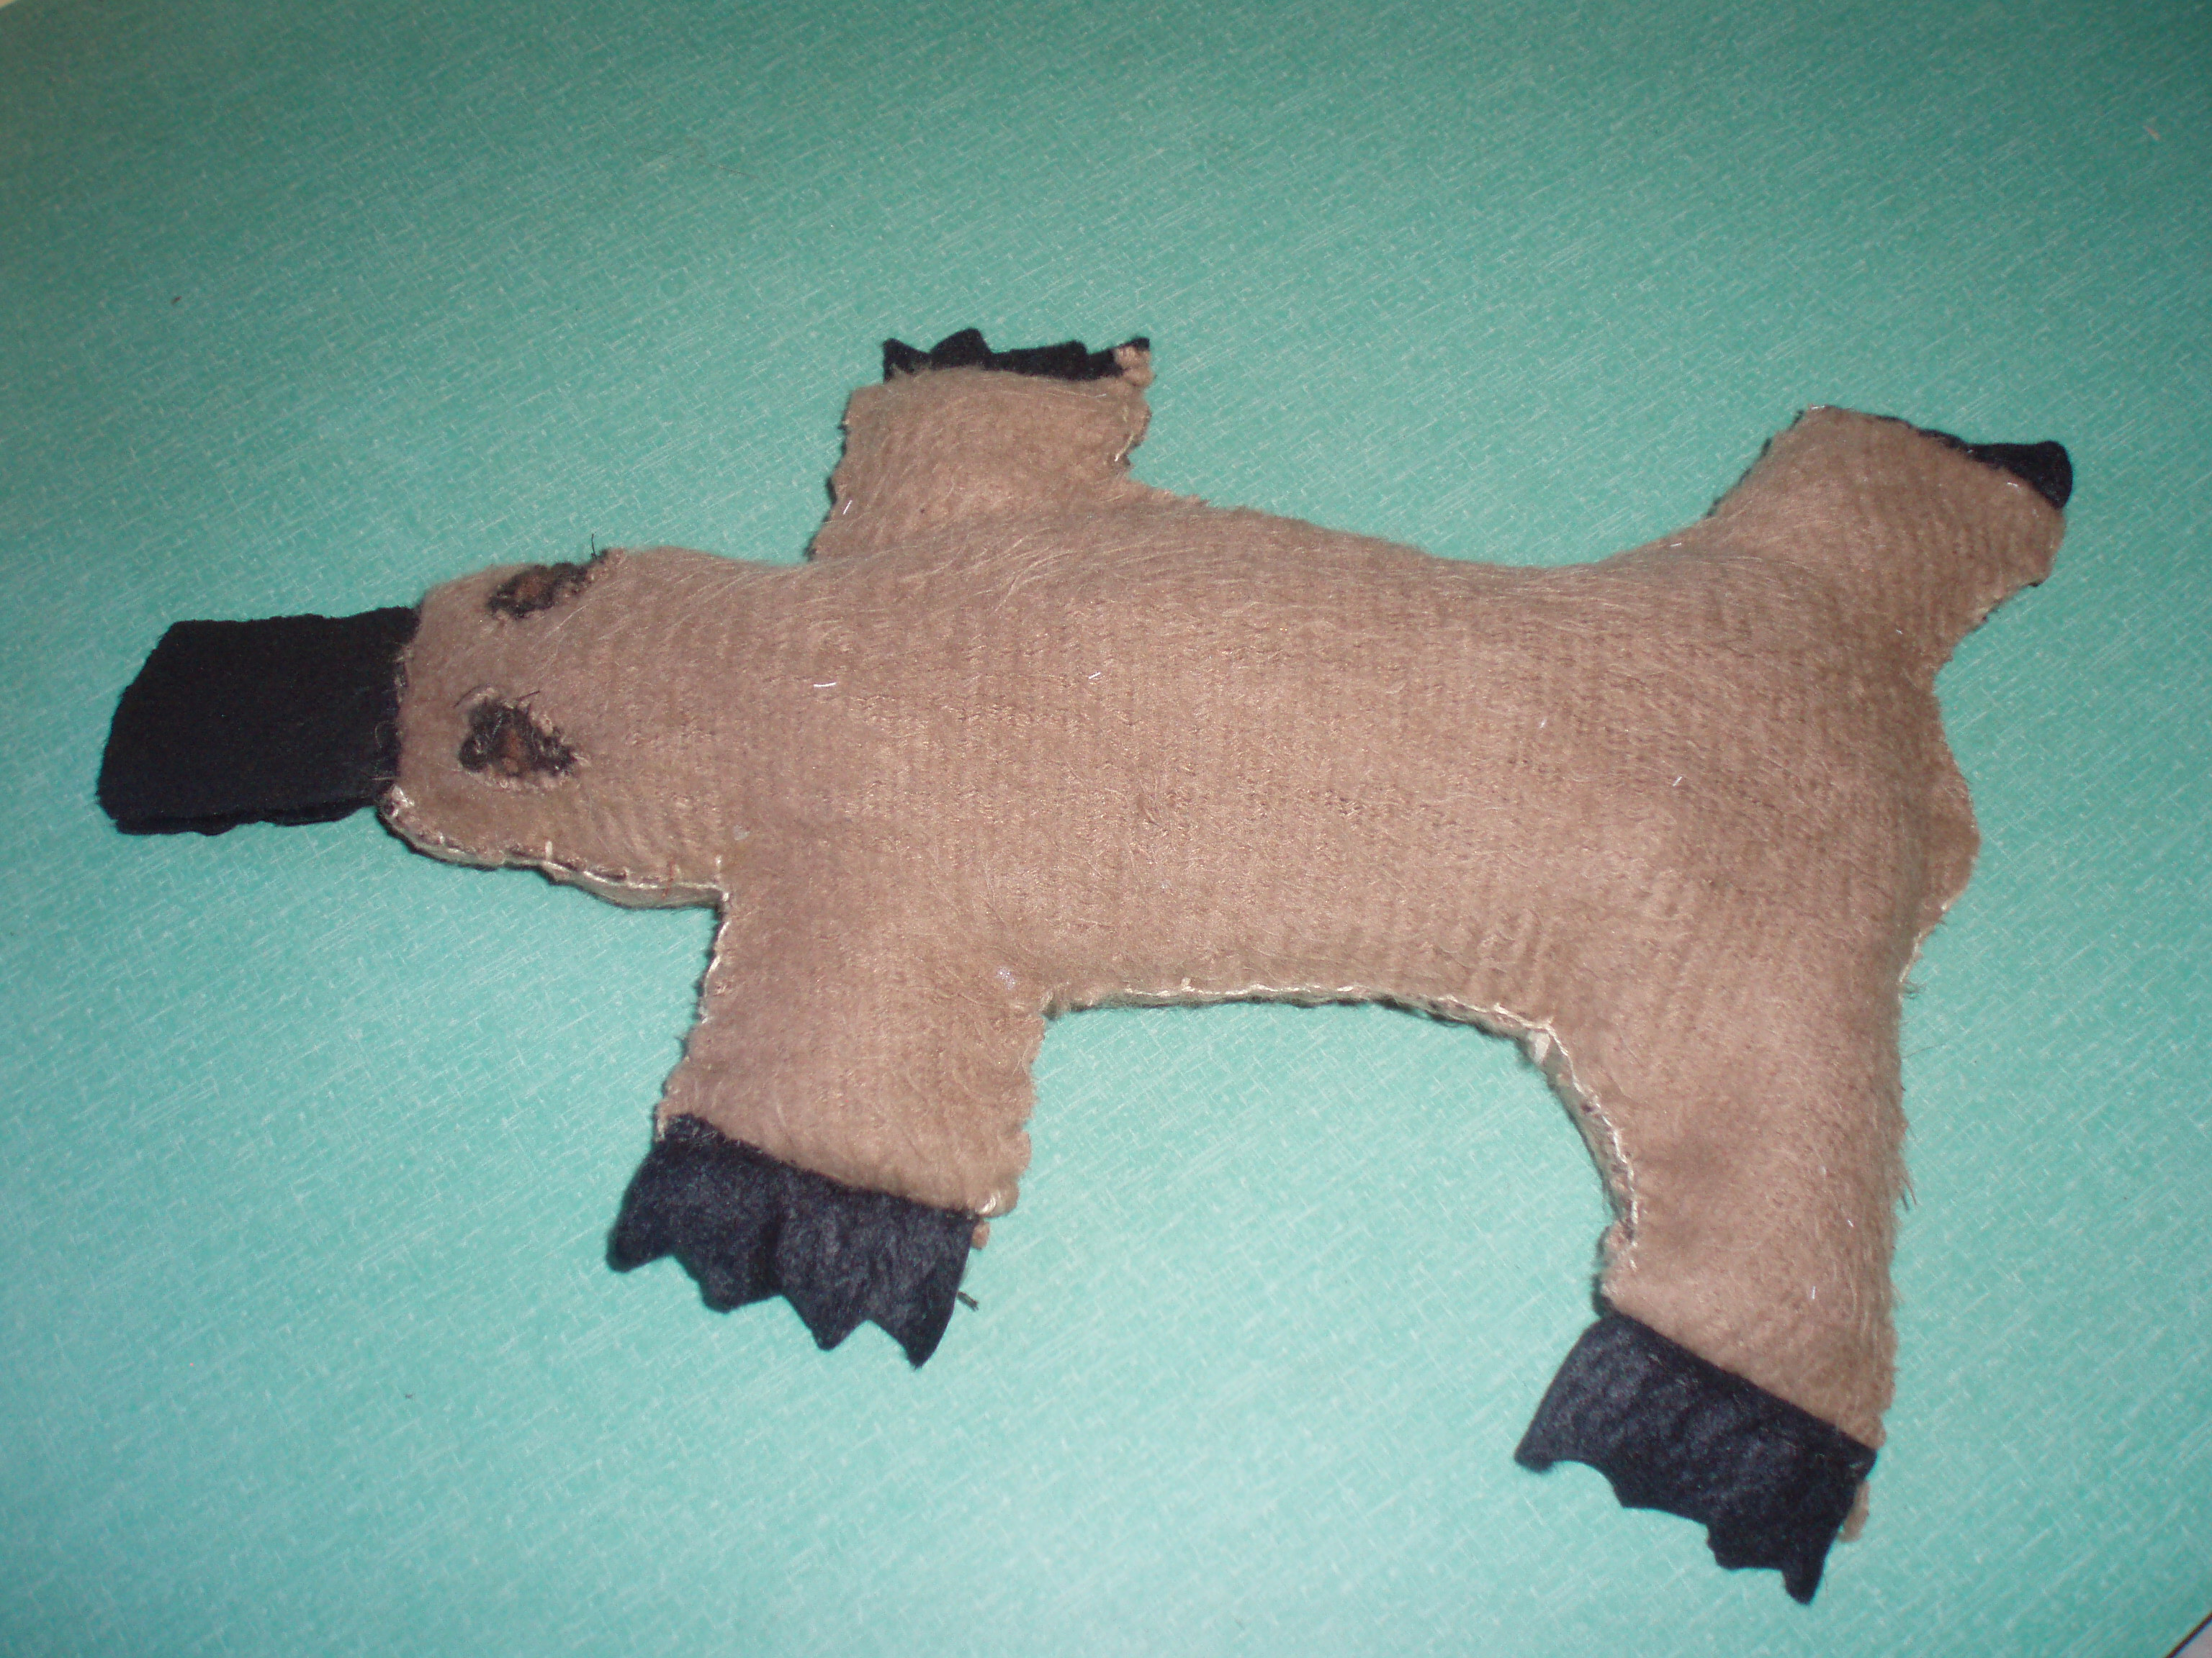
Figure 4

Shortly after completing the ‘bestiary’ I realised I had inadvertantly missed including the programme at RMIT; in response to this I made a soft sculpture in the form of a duck billed platypus (Figure 4). This native creature is an important species in evolutionary biology; it is a semi-acquatic mammal and the only one that lays eggs and produces milk. This creature is related to the multi-modal, arts as therapy focus of the RMIT programme. This programme was grounded in a humanistic, experiential approach and through the passion of the educator’s they evolved an innovative arts-based pedagogy. It began in 1996 in an environment where single art focus practices were being established as the norm (art therapy, music therapy etc). This surfaced tensions in the field around the requirement of less clinical placement hours than other masters programmes; and, the position of the multi-modal view being less valued and not included in the Australian National Art Therapy Association. Graduates responded by forming their own association (Australian Creative Arts Therapy Association - ACATA). By 2006 changes in the university organisation and financial processes resulted in the closure of the programme.
Another programme that has held a multi-modal view is the Melbourne Institute of Experiential Creative Arts Therapies (MIECAT). The cat and owl are the presence of MIECAT in both Melbourne, VIC, and at the time Brisbane, QLD (Figure 3). This is a unique programme in the private sector concerned with arts-based inquiry. It began with a focus on a phenomenological approach to the arts and evolved alongside post modern inquiry methods. It has developed an inter-subjective co-constructed view and is distinct in that it is not aligned to a professional discipline. In fact the links to therapy have been changed within its title which is now known as the Master of Arts by Supervision in Experiential and Creative Arts Practice. The approach of MIECAT is epistemologically rather than theoretically led. Where the theory of knowledge is the prevailing framework rather than a particular psychological theory.
The origins of the programme at La Trobe (deer-lady with antlers) arose near to the time when Ikon (1988), ECU (1989) and UWS (1992) were also emerging. At this time it was a Master of Counselling: The Arts in Therapy (1991-1996). It became a Master of Art Therapy in 1998 after the founding academics moved into the private sector to form MIECAT to pursue a practice of small group experiential learning not sustainable in the university context. It was then that an educator was appointed from the USA to develop the programme. The view of the La Trobe programme is one of theory driven by context within a humanistic and psychodynamic framework teaching a variety of theoretical perspectives. Educators with experiences from USA, Israel, Germany and Australia have shaped the evolution of this programme and developed its model of training which aims to produce art therapists who are also well rounded mental health professionals.
Turning attention to the programme at UQ here a fox-mother is holding two chickens in her basket. This captures the flavour of the UQ programme, which is the most recently developed (2004) and under the wing of a Masters of Mental Health within the School of Medicine. In the natural world there is an antagonism between chickens and foxes which suggests something of the relationship between the programme and its departmental position in the university. Initiated by a commited group of art therapists trained in UK and USA from psychodynamic and expressive therapies perspectives. There is a generic component of the programme that covers a broad range of mental health theory however its’ theoretical flavour was summarised as a basic psychodynamic foundation with a pragmatic and pluralistic orientation.
Reflecting back on figure 1, in the centre is a frame with a circle with a black dot surrounded by a blossoming tree and a swirling question mark. This represents an earlier image made in the research process that highlighted the importance of Indigenous Australia and a somewhat neglected issue that requires more consideration. Overall the ‘bestiary’ shows that art therapy education in Australia is populated with a variety of programmes / creatures (or approaches). Some of these have hybrid qualities or resemble something particular of the place. However a resounding factor is how grounded the field is in the relational, and shaped by its people in its own context. This led me to focus on the stories of the educators themselves and to inquire into their experiences and influences to illuminate this ‘emotional’ learning process and what is evolving in this Australian context. I traced the educators of the educators to provide a genealogical insight into where the influences have come from and how they have evolved and emerged and what is being passed onto new art therapists in the education process. Space does not permit an unfolding of this aspect. However influences from UK and USA are significant and show the cross fertilization of views and practices in the migration and adaptation of ideas from these different places.

Overview of the findings

Overall the findings revealed a diverse and multi-layered field of hybrid views and innovative approaches held within seven programmes in the public university (5) and private (2) sectors in Australia. It was found that theories and practices are closely linked and that theoretical views have evolved from the educators, their background experiences, the location of the programme within the university, professional contexts (health, arts, education, social, community) and the prevailing views within these contexts, which are driven by greater economic, socio-political forces and neo-liberal agendas. The university programmes generally teach a range of the major theories of psychotherapy underpinned with a psychodynamic or humanistic perspective. Movement towards a more integrative and eclectic approach was found. This was linked to being part of more general master programmes and economic forces. The private sector programmes are more distinctly grounded in a particular theoretical perspective or philosophical view. Important issues for art therapy education were identified as: the position and emphasis on art; working with the therapy/education tension; the gender imbalance in the profession; Indigenous perspectives; intercultural issues and difference. Inquiry into the horizons of the field revealed the importance of developing the profile of the profession, the growth of research and a trend towards discourses on arts and wellness and how art therapy education and practice is evolving more towards a social rather than a medical/health view.
The influence of the USA and UK was found to be a strong element in the research. The theme of conflict between approaches and cultures echoed the complex issues found in the beginning of the profession’s development and struggle for definition, ownership and recognition. This brought into focus the broad issue of difference and conflict and the need to understand and manage these processes at the programme and profession level. It also reflected the cultural and societal dissonance between Indigenous and other Australians. Underlining the relevance of taking a post colonial perspective to question and understand this experience to better meet the needs of people in marginal groups and to work more effectively with all kinds of intercultural relationships.
The research revealed the impact of economic and administrative issues within higher education and the significance of these forces, particularly in Australia but also in the USA and UK. The reduction in resources has led to the closure of programmes and the need to join with more generic masters programmes to survive. In some cases programmes have moved to or emerged in the private sector to enable an educational freedom not possible in the public sector. This trend of neo-liberalism can be seen across the economically developed world, producing a market-driven approach to social policy impacting on higher education and other public sector provisions. This poses a threat to the relational work of art therapy which requires investment in human resources. Despite this pressure there is an irrepressible spring for art therapy as it emerges across other countries in the region.

Developments in New Zealand and Singapore

In recent times similar professional bodies and education programmes have emerged in the Asia-Pacific region. Some of these have become linked to the profession in Australia. I was fortunate to be involved as a monitor in the development of the Master of Arts in Arts Therapy at Whitecliffe College of Arts and Design in Auckland, New Zealand (2001-2008) and more recently as an external examiner at the Master of Art Therapy at LaSalle College of the Arts in Singapore (since 2009). I have seen the ways art therapy education has evolved in these places and has sought acceptance within the international field to strengthen their standing and profile. The tension between a context relevant approach evolving and an imported model being adopted is one that recurs through the variations of this profession and practice called ‘art therapy’. The way these forces relate or become synthesized is a creative venture brokered by the individuals who shape this process in their particular contexts. In both New Zealand and Singapore a colonial background underscores their histories in different ways, which becomes a significant factor to consider.
From my observations of New Zealand which is a bi-cultural context (Maori & European). The Maori view of the arts as integrated has influenced a relatedness between all the arts therapies in the programme at Whitecliffe College. This in turn has influenced the development of the professional association (ANZATA) and its inclusion of the arts (plural) alongside the other variety of views found in programmes in Australia.
In Singapore, the programme is more nascent and holds a particular position in its intersection between Asian and Western cultures and values. The task here is to learn from histories and connect to the soul of the place in shaping its form. This development potentially has a guiding role in other art therapy ‘springs’ in the Asian region.
These observations highlight the issue of difference and the importance of developing awareness and responses to engage with the particularity of each context. This may include the geography, the position of arts in the culture, the understanding of mental health, the consequences of colonisation, migration, socio-economic and political factors; in order to develop a culturally relevant art therapy education and practice. With this knowledge we can guard against academic imperialism and erosion of differences.

Conclusion

This article has presented some key findings of a PhD research project that set out to map the field of art therapy education in Australia; charting its unique development and mix of migration and adaptation. This research experience has honed my understanding of art therapy education as an experiential, emotional and relational process, where theory becomes embodied, performed and critiqued within the frame of a guiding pedagogical relationship. This pedagogical relationship echoes the supportive parental relationship or therapeutic relationship, where enabling a student to develop confidence and potential is at its core. The more I have thought about theory, the more I have come to understand it as a set of beliefs, where the most we can hope for is insight into those beliefs and understanding of ourselves.
This leads me to reflect on the importance of the philosophy underpinning art therapy education programmes and their role in the development of in-depth critical thinking for working with highly vulnerable people in varied socio-political and cultural contexts. Difference is at the heart of the enterprise; whether the view of the programme is of a particular theory or an eclectic approach; it is the understanding of the theoretical position of the work that will strengthen its place in the greater scheme of things. Therefore I see the overarching aim of the education of art therapists is towards an understanding of a practice that integrates theoretical knowledge with a capacity to question and consider this as one position in an ever evolving context. Perhaps as artist Grayson Perry advocates we would be advised to ‘hold our beliefs lightly’.

References

Brooks, F. (1998). A black perspective on art therapy training. In D. Docktor (Ed.), Arts therapists, refugees and migrants: Reaching across borders (pp. 275-286). London: Jessica Kingsley Publishers.

Brown, C., Meyerowitz-Katz, J., & Ryde, J. (2007). Thinking with image-making: Supervising student art therapists. In J. Schaverien & C. Case (Eds.), Supervision of art psychotherapy: A theoretical and practical handbook, (pp. 167-181). London & New York: Routledge.

Campanelli, M., & Kaplan, F. (1996). Art therapy in Oz: Report from Australia. The Arts in Psychotherapy, 23(1), 61-67.

Coulter, A. (2006). Art therapy in Australia: The extended family. Australian & New Zealand Journal of Art Therapy, 1(1), 8-18.

Dudley, J., Gilroy, A., & Skaife, S. (2000). Changing gear in experiential art therapy groups. In A. Gilroy & G. McNeilly (Eds.), The changing shape of art therapy (pp. 172-199). London: Jessica Kingsley.

Edwards, C. (2007). Thinking outside the frame: A systems approach to art therapy with children. In D. Spring (Ed.), Art in treatment: Transatlantic dialogue. Springfield, Illinois: Charles C. Thomas.

Edwards, D. (1993). Learning about feelings: The role of supervision in art therapy training, The Arts in Psychotherapy, 20, 213-222.

Franklin, M., Farrelly-Hanson, M., Marek, B., Swan-Foster, N., & Wallingford, S. (2000). Transpersonal art therapy education. Art Therapy: Journal of the American Art Therapy Association, 17, 101-110.

Gerber, N. (2006). The essential components of doctoral-level education for art therapists. The Arts in Psychotherapy, 33(2), 98-112.

Gilroy, A. (1992). Art therapists and their art: A study of occupational choice and career development from the origins of an interest in art to occasionally being able to paint. Unpublished D. Phil thesis, University of Sussex.

Gilroy, A. (1998). On being a temporary migrant to Australia: Reflections on art therapy education and practice. In D. Docktor (Ed.), Arts therapists, refugees and migrants: Reaching across borders (pp. 262-277). London, UK: Jessica Kingsley Publishers.
Gilroy, A., & Hanna, M. (1998). Conflict and culture in art therapy: an Australian perspective. In A. Calisch & A. Hiscox. A. (Eds.), Tapestry of cultural issues in art therapy, (pp. 249-275). London, UK: Jessica Kingsley Publishers.

Henzell, J. (1997). Art madness and anti-psychiatry: A memoir. In K. Killick & J. Schaverien (Eds.), Art, psychotherapy and psychosis, (pp. 177-197). London, UK: Routledge.

Henzell, J. (2003). Creating art psychotherapy training in Australia: Missing years 1959-1989 Conference paper, Melbourne. http://www.ecu.edu.au/. Retrieved ECU library website July 2009.

Holloway, M. (2009). British Australian: Art therapy, White racial identity and racism in Australia. Australian & New Zealand Journal of Art Therapy, 4(1), 62-67.

Junge, M., & Asawa, P. (1994). A history of art therapy in the United States. Mundelein, IL: American Art Therapy Association.

Kapitan, L. (2010). Introduction to art therapy research. New York, NY: Taylor & Francis Group.

Knill, P., Levine, E., & Levine, S. (2005). Principles and practice of expressive arts therapy. London & Philadelphia: Jessica Kingsley Publishers.

Lewis, M. (1988). Managing madness: Psychiatry & society in Australia 1788-1980. Canberra: Australian Government Publishing Service.

Linesch, D. (2005). Supporting cultural competency in art therapy training. The Arts in Psychotherapy, 32(5), 382-394.

Linnell, S., Perry, S., Pretorius J., Westwood, J. (2007) Where knowing and not knowing touch (Art and the unconscious). Exhibition and Catalogue: At The Vanishing Point Contemporary Art, Newtown, Sydney, NSW, Australia (27 Sept-7 Oct).

Linnell, S., Perry, S., Pretorius, J. & Westwood, J. (2011) Where knowing & not knowing touch (Art & the unconscious) Film and statement. ATOL: Art Therapy On Line, 1(3). Goldsmiths: UK, http://eprints-gojo.gold.ac.uk/atol/home

McLeod, J. (2006). Qualitative research in counselling and psychotherapy. London,
UK: Sage.

McNiff, S. (1986). Educating the creative arts therapist: A profile of the profession. Springfield IL: Charles C Thomas.

Menahemi, H. (2006). Experience and dilemmas of experiential group art therapy in art therapy training programs. Australian and New Zealand Journal of Art Therapy, 1(1), 19-24.

Moon, B. (2003). Essentials of art therapy education and practice. Springfield IL: Charles C.Thomas.

Reynolds, H. (2001). An indelible stain? The question of genocide in Australia’s history. Ringwood, Victoria, Australia: Viking.

Skaife, S. (2007). Working in black and white: An art therapy supervision group. In J. Schaverien & C. Case (Eds.), Supervision of art psychotherapy: A theoretical and practical handbook (pp. 139- 152). London & New York: Routledge.

Skaife, S., & Jones, K. (2009). The art therapy large group as a teaching method for the institutional and political aspects of professional training. Learning in Health and Social Health Care, 8(3), 200-209.

Waller, D. (1991). Becoming a profession: The history of art therapy in Britain 1940-1982. London, UK: Tavistock/Routledge.

Waller, D. (1992). The training of art therapists, past, present and future issues. In D. Waller & A. Gilroy (Eds.), Art therapy: A handbook (pp. 211-228). Buckingham, Philadelphia: Open University Press.

Waller, D. (1998). Towards a European art therapy. Buckingham, UK: Open University Press.

Waller, D., & James, K. (1984). Training in art therapy. In T. Dalley (Ed.), Art as therapy, (pp. 191-201). London: Tavistock.

Ward, C. (1998). Art therapy training and race and culture. In D. Docktor (Ed.), Arts therapists, refugees and migrants: Reaching across borders, (pp. 287-305). London: Jessica Kingsley Publishers.

Westwood, J. (2010) Hybrid Creatures: Mapping the emerging shape of art therapy education in Australia. PhD thesis, University of Western Sydney, Australia. http://handle.uws.edu.au:8081/1959.7/506680

The philosophical theory of knowledge.
Syncretism is the attempt to reconcile disparate or contrary beliefs of various schools of thought. The syncretic context is one where extreme differences are upheld, and where each element enriches the others within the array of their differences.
Ethical approval was undertaken and granted using the National Ethics Application Form through UWS Ethics Committee 2 June 2008.
A bestiary is a compendium of illustrations of beasts or animals which are usually accompanied by a moral lesson.
This iconography evolved as an imaginative response to the investigation. Its’ origins are difficult to define although links to my own artistic preoccupations with hybrid animal imagery, my sense of migration and the ghosts of colonial language could be made.
The scope of this research was limited to the Ikon Institute however the transpersonal art therapy programme also became connected to the Phoenix Institute. See. http://phoenixinstitute.com.au
This is metaphorical and related to tensions between arts and medical sciences.
Neo-liberalism can be described as an ideological paradigm that seeks to maximize the role of the private sector and shift risk from governments and corporations onto individuals.
See www.victoria-miro.com

