TITLE: Empathic-like responding by domestic dogs (Canis familiaris) to distress in humans: An exploratory study

Deborah Custance and Jennifer Mayer

Goldsmiths College, Department of Psychology, 8 Lewisham Way, New Cross, London SE14 6NW, UK. Tel. +44 (0)20 7919 7897, +44 (02) 7919 7873
Abstract

Empathy covers a range of phenomena from cognitive empathy involving metarepresentation to emotional contagion stemming from automatically triggered reflexes. An experimental protocol first used with human infants was adapted to investigate empathy in domestic dogs. Dogs oriented toward their owner or a stranger more often when the person was pretending to cry than when they were talking or humming. Observers, unaware of experimental hypotheses and the condition under which dogs were responding, more often categorized dogs’ approaches as submissive as opposed to alert, playful or calm during the crying condition. When the stranger pretended to cry, rather than approaching their usual source of comfort, their owner, dogs sniffed, nuzzled and licked the stranger instead. The dogs’ pattern of response was behaviorally consistent with an expression of empathic concern, but is most parsimoniously interpreted as emotional contagion coupled with a previous learning history in which they have been rewarded for approaching distressed human companions.

Key words: empathy, emotional contagion, domestic dogs

Dogs and humans have shared a symbiotic bond for at least 15,000 years (Miklósi 2008; Savolainen et al. 2002). Over that period dogs have been subject to intense selective breeding that has not only produced breeds with markedly different body shapes and sizes but also differing behavioral dispositions (Scott & Fuller 1974). Hare et al. (2002) have argued that the process of domestication has also conveyed advanced socio-cognitive abilities to dogs (e.g., Hare & Tomasello 2006; Tópal et al. 2006; Kaminski et al. 2009). In addition, it has been suggested that domestication has led to a strong predisposition in dogs to form close affectional bonds with humans (Tópal et al. 1998; Prato-Previde et al. 2003; Palmer & Custance 2008). The genetic basis of this process has been well established in silver foxes (Vulpes vulpes) which over the course of 30 years of selective breeding not only became increasingly tame and friendly toward humans, but also developed a dog-like appearance with floppy ears, spotty coats and curly tails (Belyaev et al. 1981; Trut et al. 2002).
One aspect of the dog-human affectional bond, often sited by pet-owners, is the fact that dogs seem empathically well-tuned to human emotions (Vitulli 2006). They appear to celebrate our joy and commiserate our sorrow. Although owners readily report empathic-like responding in their pets, systematic empirical confirmation remains elusive (Silva & de Sousa 2011). Although it has been found that dogs will contagiously yawn in response to a human yawning (Joly-Mascheroni et al. 2008) such behavior seems very different from empathically responding to human emotional displays such as distress. Zahn-Waxler et al. (1984) in a study on empathy in human infants noted that some household dogs appeared to respond empathically when their owner pretended to cry. However, the report of this behavior constituted little more than an anecdotal observation.
Despite over a century of interest, no consensus exists over a proper definition of empathy. Although its linguistic roots are in ancient Greek, the word empathy was first introduced relatively recently into modern usage in the context of the philosophy of aesthetics. It was originally used to refer to “feeling into” works of art or nature (Titchener 1909). However, from the mid 20th century onwards, empathy became a focus of psychological research in the context of social communication and pro-sociality (Silva & de Sousa 2011). Although there seem to be as many definitions of the term as researchers interested in it, empathy has broadly been defined as, “the naturally occurring subjective experience of similarity between the feelings expressed by self and others without loosing (sic.) sight of whose feelings belong to whom” (Decety & Jackson 2004, p. 71).
Developmental and comparative psychologists have identified a number of empathy-related phenomena involving varying degrees of cognitive complexity (e.g., Eisenberg 2009, Preston & de Waal 2002). Batson et al. (1981) were among the first to distinguish empathy from personal distress. Both processes are underpinned by emotional contagion in which perceiving another’s emotional state triggers a similar emotional response in an observer. Yet, whilst personal distress is self-oriented, empathy is other-oriented (Batson 1991). Eisenberg (2009) defined personal distress as, “self-focused, aversive emotional reaction to the vicarious experiencing of another’s emotion … that is associated with the egoistic motivation of making oneself feel better” (p. 126). Thus, upon witnessing another infant cry an observing infant may also start to cry, but instead of offering aid to the initially distressed individual the observing infant seeks comfort for her own vicariously triggered distress.
In contrast to personal distress, whilst empathizing individuals still experience a vicarious emotional reaction to the emotional state displayed by others, they do not become entirely focused upon their own emotional response. As such, empathy requires a capacity for self-other differentiation (Preston & de Waal 2002; de Waal 2008). The empathizer’s response to the other’s emotional state is primarily focused upon or oriented toward the other rather than themselves. Hence, a behavioral indicator of empathy may be comfort-offering or helping behavior in response to another’s distress.
Some theorists have also discussed another highly cognitively complex category of empathy-related processing, sometimes labeled sympathy (e.g., Eisenberg 2009) or cognitive empathy (e.g., Preston and de Waal 2002). Eisenberg (2009) defined it as, “an affective response that frequently stems from empathy, but can derive solely (or partly) from perspective taking or other cognitive processing, including retrieval of information from memory. It consists of feelings of sorrow or concern for the distressed or needy other rather than feeling the emotion as the other person is experiencing or expected to experience it” (p. 126). Such a highly complex category of empathic responding would be extremely difficult to establish empirically without the aid of verbal self-report. Thus, it seems unlikely that one could provide convincing evidence of sympathy in non-verbal participants such as very young human infants or non-human animals.
Although it would be very difficult to establish a capacity for sympathy in non-human animals, there is growing evidence that many species are nevertheless sensitive to distress in others. Rats (Church 1959) and monkeys (Wechkin et al. 1964) have been found to forgo food in order to avoid delivering electric shocks to conspecifics. Mice have shown increased sensitivity to their own pain when paired with familiar mice experiencing a different type of pain (Langford et al. 2006). Additionally, there is evidence of empathic concern in chimpanzees, cats and dogs (Zahn-Waxler et al. 1984; Yerkes 1925; Ladygina-Kohts 1935/2001), yet this is largely anecdotal. There is, however, systematic observational data on post-conflict “consolation” in apes (de Waal & van Roosmalen 1979), rooks (Seed et al. 2007) and domestic dogs (Cools et al. 2008). Such consolatory behavior involves a third party approaching and often making physical contact with either the winner or loser of a former altercation. Yet the degree to which this functions as comfort-offering is not clear, since there is little evidence of stress alleviation as a result of such post-conflict affiliation (Koski & Sterck 2007).
As indicated above, most evidence of empathy related behavior in non-human animals involves intraspecies responding. The anecdotal observations of dogs are of particular interest since they often involve interspecies (i.e., dog to human) empathic-like behavior. The distress signals of humans are very different to those of dogs. Nevertheless, one might expect a predator/scavenger, such as a dog, to be predisposed to respond to the distress signals of other species. However, rather than provoking empathic-like responding, it seems just as likely that distress in an interspecific would provoke alert or predatory related behavior in dogs. It is not immediately clear how one might expect a dog to respond to distress in humans.
There has been some experimental study of empathically motivated help-seeking in dogs. Macpherson and Roberts (2006) found that pet dogs failed to seek the help of a human bystander when their owner feigned a heart attack or was pinned by a bookcase. The authors concluded that the “dogs did not understand the nature of the emergency or the need to obtain help” (p. 113). But, seeking help from a bystander is a rather complex type of empathic responding. We set out to investigate a slightly less complex scenario. How do dogs respond when humans suddenly begin to cry for no readily apparent reason?
It has been found that when typically-developing human infants are faced with suddenly crying individuals, they will often hug, pat, make appropriate verbal utterances (e.g., “there, there”, “it’s okay”), offer toys, and sometimes recruit assistance (Zahn-Waxler et al. 1979; Zahn-Waxler et al. 1984). The behavior of dogs under similar circumstances is harder to interpret. Dogs can whine, nuzzle, lick, lay their head in the person’s lap or fetch toys. Yet, such behavior could be an expression of contagious distress and egoistic comfort-seeking rather than empathically motivated comfort-offering. Alternatively, such behavior could be motivated by curiosity. Hence, the primary challenge in investigating possible empathy in dogs is devising an experimental procedure that can elucidate the distinction between curiosity, egoistic attention- or comfort-seeking and expressions of genuine empathic concern.
In an attempt to solve this conundrum, we modified Zahn-Waxler et al.’s (1984) procedure to include a condition in which an unfamiliar person also pretended to cry. If the dogs were principally seeking comfort for themselves, we predicted that they would avoid the crying stranger and approach their owner instead. If the dogs’ approach was principally motivated by curiosity, we predicted that any relatively uncommon behavior, of a similar intensity to crying, would elicit approach. Therefore, we included a condition in which the owner and stranger took turns humming in a strange staccato manner. We also compared the dogs’ behavior in response to crying and humming with periods in which the humans were talking. Talking is a very common human activity for dogs to witness and thus it served as a baseline condition with which to compare their responses to the rather strange or uncommon crying and humming behavior. Finally, we also evaluated the emotional tone of the dogs’ approaches during the different conditions (i.e., crying, humming and talking). If the dogs were exhibiting contagiously triggered personal distress or empathy one would expect them to behave in a subdued, submissive manner rather than being playful, neutrally calm or alert.

Method

Participants
Eighteen medium-sized domestic dogs (Canis familiaris) from the North West USA participated in the study. There were 9 females and 9 males of various breeds (10 mongrels, three Labradors, two Golden Retrievers, one Vizsla, one Belgian Shepherd and one Beagle) with a mean age of 9 years and 9 months ranging from 8 months to 12 years. Twelve dogs had been adopted by their current owners from a canine rescue centre. The remaining six were acquired either from a breeder or the litter of a personal acquaintance. All were household pets with no specialist training beyond basic obedience.
Eighteen owners (one per dog) comprising 14 women and 4 men ranging from 34 to 72 years of age also participated in the study. Length of ownership ranged from two months to twelve years. When owners were asked how responsive their dog had been to emotions in humans previously, 15 dogs were anecdotally reported to have responded (11 to sadness, seven to pain, eight to anger, and nine to celebration).

Testing Conditions and Materials
In order to ensure that the dogs remained relatively unstressed during the experiment, and were thus more likely to behave in a natural manner, they were tested in the living-room of their own home. The owner and stranger remained seated at least two meters apart throughout the procedure, whilst a third person stood discreetly in one corner of the room and recorded the dog’s behavior on a Sony Handicam® camcorder.

Procedure
Each dog was exposed to four separate 20 second long experimental conditions in which: 1) their owner cried; 2) a stranger cried; 3) their owner hummed; 4) the stranger hummed. The order of who performed first (i.e. stranger or owner) and whether they cried or hummed was counterbalanced. In addition, each crying or humming condition was preceded by two minutes during which the owner and stranger talked.
The same person played the role of stranger throughout (i.e., the second author, J. Mayer). She was entirely unfamiliar to the dogs prior to testing. From the moment of entering their house, the stranger ignored the dogs: she did not look directly at them or make any friendly overtures. By the time testing began, all dogs showed little interest in the stranger. As a result, when 20 seconds of the dogs’ behavior was sampled one minute into the procedure (during which the owner and stranger were talking), 15 dogs were passive, two were walking and one was playing. Thus, the dogs were not overly fixated upon the stranger nor did they show any aggressive territoriality.
The owners were given the following instructions concerning their role during each condition: Crying: When you are asked to cry, please pretend to cry to the best of your ability for 20 seconds; you will be told when you can stop. The only gestures you should make while you are pretending to cry are either leaning forward or covering your face. Humming: When you are asked to hum, please loudly hum the nursery rhyme “Mary Had a Little Lamb” to the best of your ability for 20 seconds; you will be told when you can stop. Please hum at approximately the same volume and perform the same gestures as you did or will do during the crying condition. The owners were also asked not to refer to their dog by name, look directly at him or her or initiate physical contact during testing.
Once the owner had been briefed, the video-camera was turned on and the testing session began. For the first two minutes the stranger asked the owner questions from a previously prepared list about the dog’s biographical details along with soliciting anecdotal reports regarding the dog’s previous reactions to various emotional displays in humans. When two minutes had elapsed, the first bout of crying or humming was performed. Immediately following this bout, the owner and stranger returned to talking thereby allowing the dog’s behavior to normalize. Thus, a total of two bouts of crying and two of humming were performed, each separated by two minutes of talking.

Behavioral Analysis
The 20-second humming and crying conditions from the digital video recordings of the testing sessions were analyzed using 5-second point and time sampling (Martin & Bateson 2007). Because we also wished to compare the dogs’ responses to humming and crying with that of talking, we sampled two 20-second phases during which the owner and stranger talked. The first sample commenced one minute after the start of the experiment and the second sample was taken 30 seconds after the second crying/humming phase.
Six different behaviors, divided into two categories, were scored via 5-second point-sampling. The category “person-oriented” included “look at”, “approach” and “contact” whilst “non-person-oriented” included “passive”, “walking”, and “solitary play” (Table 1). Thus, after every 5-second interval the behavior displayed by the dog at that precise moment was recorded.

INSERT TABLE 1 ABOUT HERE

Since vocalizing was not a mutually exclusive behavior (i.e., it could co-occur with any of the other behaviors) and it was a rare and transient event, it was scored differently using 5-second time- rather than point-sampling. Thus, if the dog made any vocalization during each 5-second interval, this was scored as one and the type of the vocalization was noted.
The second author (J. Mayer) scored all of the testing sessions and a naïve observer, who was unaware of the study’s hypotheses, scored a random selection of four sessions (i.e., 4 out of 18 dogs or 22% of the sample). During naïve scoring, a DVD without sound or labels was used so that the naïve observer remained as far as possible unaware of the experimental conditions or hypotheses. Inter-observer agreement was very good: Cohen’s κ = 0.83.
In addition to the basic behaviors outlined above, we also wished to evaluate the emotional tone of the dogs’ approaches to the stranger and owner to see if they approached in a different manner when the humans were crying, humming or talking. Four emotional states in dogs were considered: submissive, calm, playful and alert. These four relatively mild emotional displays were chosen because the other more extreme emotional signals described in dogs such as fearfulness or aggression were not evident in any of the subjects. (For reasons of welfare, the procedure would have been curtailed if any of the dogs had displayed strong fear or aggression.). Three exemplars of each emotion (two photographs and a line drawing) were selected from a Google© image search. An opportunity sample of 10 experienced dog-owners, who were unaware of the experimental hypotheses, were asked to identify which of the four emotional states the dogs in the pictures were displaying. There was 100% agreement between the observers on all but three of the 12 images. These three pictures were discarded and the remaining images were used to develop pen drawings of each of the relevant emotional state postures (Figure 1).

INSERT FIGURE 1 ABOUT HERE

Three other independent observers, all of whom were experienced dog-owners and unaware the study’s hypotheses, were shown the four pen drawings along with short descriptions of each emotional display.
Calm (relaxed or neutral): The dog’s ears are held down but not laid flat and back (or if it is a breed that holds its ear up all the time, such as a Doberman pincher or German Shepherd, the ears are not pricked forward). The mouth is often open and the tongue is out or in view. The tail is held in a neutral position (not between the legs, but not held up toward horizontal or higher).
Submissive (mildly worried or concerned): The dog’s body and head is slightly lowered. They hold their ears flat and back. Their tail is held low and sometimes slightly between their legs. They will also sometimes wag their tail with a rapid side to side motion. They will sometimes protrude their tongue slightly and raise one leg in a hesitant placating manner.
Alert: The dog’s ears are pricked and forward (some breeds cannot prick their ears, but if possible they hold them up slightly). The body is slightly raised and the legs stiff. The dog stares in a fixed manner and its tail is held up so that it is horizontal or higher.
Playful: The dog moves in an exuberant, excited manner, the tail is held up (often wagging) and the dog’s face assumes a happy or excited expression with the mouth often held slightly open. When requesting play dogs will sometimes assume a “bow” posture: they lower their front legs and raise their hind quarters with their tail held up.
The three observers watched silent footage of all the dogs’ approaches in the crying and humming conditions (none of the dogs approached during talking). They were asked to select which emotional category best fitted the nature of the dog’s approach. The agreement between observers was moderate to good: observer A to B Cohen’s κ = 0.685, observer A to C Cohen’s κ = 0.463, and observer B to C Cohen’s κ = 0.618. In 18 out of the 29 (67%) crying and humming bouts in which approaches occurred, all three observers agreed on the nature of the dogs’ approaches. In the remaining nine bouts (33%) at least two observers agreed on the nature of the approach. Therefore, the emotional tone of the dogs’ approaches during each bout of crying or humming was taken to be that category upon which two or more of the observers agreed.

Results

Table 2 presents a summary of the point and time sample data. According to the time sample data, significantly more dogs approached during crying (N = 15) than humming (N = 6) (McNemar test X²(1, N = 18) = 7.11, p = .008). None of the dogs approached during talking. Only two dogs vocalized during testing. One dog whined when its owner pretended to cry, the other produced a trilled-whimpering in response to the crying bouts of both the owner and stranger.

INSERT TABLE 2 ABOUT HERE

There was a significant main effect for the degree of person-oriented behaviors (i.e., the combined point sample scores for look at, approach and contact) performed during the crying, humming and talking conditions (repeated measures ANOVA, F(1.36, 23.03) = 51.29, p < .001, Fig. 2). Bonferroni corrected post hoc tests showed that dogs were significantly more person-oriented during crying compared to humming (p < .001) or talking (p < .001). Despite responding more strongly to crying, the dogs still differentiated between humming and talking, since there was a significantly higher rate of person-oriented behaviors performed during humming versus talking (p = .045 one-tailed).

INSERT FIGURE 2 ABOUT HERE

As mentioned earlier, it was hypothesized that if the dogs were behaving in a manner consistent with empathy, they would direct more behavior toward the person who was crying than the silent witness. If, however, they approached their owner when the stranger was crying, this might suggest they were comfort-seeking. To test these hypotheses, a 2X2 repeated measures ANOVA was conducted on the dependent variable of number of person-oriented behaviors performed by dogs during the crying condition. The independent variables were identity of person performing (owner/stranger) and behavior being responded to (crying/sitting silently). There was no significant main effect of identify of person performing (F(1,17) = .04, p = .843). Thus, dogs did not perform significantly more person-oriented behavior toward the owner versus the stranger or vice versa. However, there was a significant main effect for behavior being responded to (F(1,17) = 79.12, p < .001). Dogs directed significantly more person-oriented behaviors toward the person crying than the silent companion (p < .001, Fig. 3). There was no significant interaction between the identity of the person performing and the behavior being responded to (F(1,17) = .054, p = .819).

INSERT FIGURE 3 ABOUT HERE

Although the point sample data indicated that the dogs oriented more to the humans when they were crying versus humming or talking, this does not automatically mean that they were responding in a manner consistent with empathy. If they approached in a playful or alert manner, this would be inconsistent with an expression of empathic concern. Thus, we went on to analyze the independent observers’ ratings of the emotional tone of approaches made by the dogs during crying. (As noted earlier, there were no approaches during talking and only six dogs approached during humming, which meant it was not possible to perform statistical analyses upon these data.)
Of the 15 dogs who approached during the crying condition, 13 were judged to have done so in a submissive manner; one dog was judged as alert and another dog approached the crying stranger in a playful manner and his owner in an alert manner. Since there were four possible emotional displays (submissive, alert, playful and calm), the null hypothesis was that there would be an equal probability of the dogs displaying any one of them. Thus, a non-central binomial test with a probability of 0.25 was applied to the data. It was found that a much higher proportion of the sample of dogs that approached during crying did so in a submissive manner than one would expect if the emotional type of approach displayed were equiprobable (p < .001).

Discussion

There are many different ways in which dogs could respond to an apparently distressed human. They could fail to respond at all and ignore the crying person; they could become fearful and avoidant, even approaching another calm human for reassurance; they could become alert and even act in a dominant manner towards an apparently weakened individual; they could become curious or playful; or they could approach and touch the distressed person in a gentle or submissive manner thereby providing reassurance or comfort. The majority of dogs in the present study behaved in a manner that was consistent with empathic concern and comfort-offering. The dogs responded to their owner and the stranger when they were crying in a markedly differently manner compared to when they were humming or talking. They oriented toward the person (i.e., looking at, approaching and touching them) significantly more during the crying condition than the humming or talking conditions. Of the 15 dogs that approached during the crying condition, the majority of them did so in a submissive rather than playful, calm or alert manner.
The fact that the dogs differentiated between crying and humming indicates that their response to crying was not purely driven by curiosity. The humming was designed to be a relatively novel behavior, which might be likely to pique the dogs’ curiosity. However, it was somewhat similar to talking and one might suspect that the dogs did not respond to it because they treated it as equivalent to talking. Although humming did not provoke approach or contact, the dogs nevertheless looked at the humming person significantly more often than they looked during talking. Thus, they seemed to notice that humming was different from talking, but they did not become sufficiently interested or aroused during humming to approach or touch the person performing the behavior. In addition, the two dogs who produced mild distress vocalizations during the procedure only did so during the crying condition. Thus, it seemed that crying carried greater emotional valence for the dogs and provoked a stronger overall response than either humming or talking.
It is possible that the dogs’ response to crying was driven principally by emotional contagion. The crying could have triggered personal distress in the dogs so that their approaches were driven by a desire to gain comfort for themselves rather than to offer comfort to the human. However, if the dogs’ approaches during the crying condition were entirely motivated by egoistic comfort-seeking, one might expect them to be more likely to approach their usual source of comfort (i.e. their owner) in preference to the stranger. Yet, no such preference was found. The dogs approached whoever was crying regardless of their identity. In addition, when the person who was crying ignored them (as they were instructed to do), if the dogs were egoistically motivated, one might expect them to turn to the other available non-crying person for comfort, particularly if that person were their owner. However, only two dogs approached both people during the crying condition (one approached the crying stranger first and then her owner, the other approached the calm stranger prior to going over to his crying owner and then when the stranger was crying approached the stranger prior to his owner). Thus, the dogs’ behavior was not strongly consistent with what one would expect if they were only egoistically comfort-seeking.
Even if the dogs’ pattern of response exceeded what one would expect of personal distress and egotistic comfort-seeking, it does not automatically follow that they were empathizing in the sense of making a self-other differentiation. A more parsimonious explanation of their behavior is that they may have previously received positive reinforcement for approaching crying individuals. Any household dog who approaches a distressed human family member is likely to be positively reinforced by receiving affection. Through the process of generalization, any human who then cries in the presence of that dog is likely to initiate a conditioned approach response. Since the dog is nonetheless affected by emotional contagion the response will still tend to be submissive in its emotional tone. Thus, the behavioral outcome is a response to human distress that is consistent with an expression of empathic concern, but which may not actually involve the requisite self-other differentiation needed for it to count as true empathy.
Similarly, there is no compelling evidence to suggest that the dogs’ behavior indicated sympathy or cognitive empathy. Cognitive empathy would require them to exhibit some understanding of the mental perspective of the crying humans. Sympathetic humans can produce verbal utterances such as, “Are you okay?” or, “What is the matter?” which indicate that they are engaging with or asking after the mental perspective of the crying person. Without the benefit of such verbal responses, it is difficult to imagine what behavior a dog could produce under such circumstances which could convincingly indicate mental perspective-taking.
In conclusion, we in no way claim that the present study provides definitive answers to the question of empathy in dogs. Nevertheless, we believe it sets out a profitable direction for further study. There are many more possible avenues of inquiry. For example, what is the effect of breed? Nearly all the dogs in our sample were medium-sized mongrels or hunting breeds. How would toy breeds respond? If learning history is important, a developmental study with puppies might reveal important trends. In addition, contrasting dogs with different rearing histories, such as shelter dogs or highly trained working dogs, might reveal systematic differences. It might be profitable to study other emotions in contrast to crying. It is possible, as mentioned earlier, that humming was too similar to talking to provoke a strong response. On reflection, it might have been better to have contrasted crying with laughing. Laughing is a human emotional display that has a similar auditory intensity to crying, but one might expect it to provoke a playful rather than submissive approach. The crying behavior in the present study was devoid of context. Future studies could provide a context for the emotion being displayed, such as fear caused by a snake or pain caused by stubbing one’s toe. The experimental paradigm we have developed offers a powerful new way to address many of these questions.
References

Batson CD (1991) The Altruism Question: Toward a social-psychological answer. Erlbaum Associates, Hillsdale
Batson CD, Duncan BD, Ackerman, P, Buckley, T, & Birch, K. (1981) Is empathic emotion a source of altruistic motivation? J Pers Soc Psychol 40: 290-302
Belyaev DK, Ruvinsky AO, Trut LN (1981) Inherited activation-inactivation of the star gene in foxes. J Heredity 72: 264–274
Church RM (1959) Emotional reactions of rats to the pain of others. J Comp Physiol Psychol. 52: 132-34
Cools AKA, van Hout AJ, Nelissen MHJ (2008) Canine reconciliation and third-party-initiated postconflict affiliation: Do peacemaking social mechanisms in dogs rival those of primates? Ethol 114: 53-63
Decety J, Jackson PL (2004) The functional architecture of human empathy. Behav Cog Neurosci Rev 3: 71-100
De Waal FBM (2008) Putting the altruism back into altruism: The evolution of empathy. Annu Rev Psychol 59: 279-300
De Waal FBM, van Roosmalen A (1979) Reconciliation and consolation among chimpanzees. Behav Ecol Sociobiol 5: 55-66
Eisenberg N (2009) Empathy-related responding: links with self-regulation, moral judgment, and moral behavior. In: Mikulincer M & Shaver PR (eds) Prosocial Motives, Emotions and Behavior: The better angels of our nature. American Psychological Association, Washington, DC, pp 129-148
Hare B, Brown M, Williamson C, Tomasello M (2002) The domestication of social cognition in dogs. Science 298: 1634-36
Hare B, Tomasello M (2006) Human-like social skills in dogs? Trends Cogn Sci 9: 439-44
Joly-Mascheroni RM, Senju A, Shepherd AJ (2008) Dogs catch human yawns. Biol Lett 4: 446
Kaminski J, Bräuer J, Call J, Tomasello M (2009) Domestic dogs are sensitive to a human’s perspective. Behav 146: 979-998
Koski SE, Sterck EHM (2007) Triadic postconflict affiliation in captive chimpanzees: Does consolation console? Anim Behav 73: 133-142
Ladygina-Kohts NN (1935/2001) Infant chimpanzee and human child: a classic 1935 comparative study of ape emotions and intelligence. Oxford University Press, Oxford

Langford DJ, Crager SE, Shehzad Z, Smith SB, Sotochinal SG et al (2006) Social Modulation of Pain as Evidence for Empathy in Mice. Science 312: 1967-1970
Martin P, Bateson P (2007) Measuring behaviour: an introductory guide. Cambridge Univ. Press, Cambridge
Macpherson K, Roberts WA (2006) Do dogs (Canis familiaris) seek help in an emergency? J Comp Psychol 120: 113-119
Miklósi Á (2008) Dog Behaviour, Evolution, and Cognition. Oxford Univ. Press, Oxford.
Palmer R, Custance, D (2008) A counterbalanced version of Ainsworth’s Strange Situation Procedure reveals secure-base effects in dog–human relationships. Appl Anim Behav Sci 109: 306-319
Prato-Previde E, Custance, DM, Spiezio C, Sabatini F (2003) Is the dog–human relationship an attachment bond? An observational study using Ainsworth’s strange situation. Behav 140: 225–254
Preston SD, de Waal FBM (2002) Empathy: Its ultimate and proximate bases. Behav Brain Sci 25: 1-72
Savolainen P, Zhang Y, Luo J, Lundeberg J, Leitner T (2002) Genetic evidence for East Asian origin of domestic dogs. Science 298: 1610-1613
Scott JP, Fuller J L (1974) Dog Behavior: The genetic basis. University of Chicago Press, Chicago
Seed AM, Clayton NS, Emery NJ (2007) Postconflict third party affiliation in rooks Corvus frugilegus. Curr Biol 17: 152-58
Silva K, de Sousa L (2011) 'Canis empathicus'? A proposal on dogs' capacity to empathize with humans. Biol Lett 7: 489-492
Titchener EB (1909) Lectures on the experimental psychology of thought-processes. Macmillan, New York
Topál J, Byrne RW, Miklósi Á, Csányi V (2006) Reproducing human actions and action sequences: “Do as I do!” in a dog. Anim Cogn 9: 355-67
Topál J, Miklósi Á, Csányi V, Dóka A (1998) Attachment behavior in dogs (Canis familiaris): A new application of Ainsworth’s (1969) strange situation test. J. Comp. Psychol. 112: 219-229
Trut LN, Kharlomova AV, Kukekova AV, Acland GM, Carrier, DR, Chaes K, Lark KG (2002) Morphology and Behavior: Are they coupled at the genome level? In: Ostramder EA, Giger U, Lindblad-Toh K (eds) The Dog and Its Genome. Cold Harbor Springs Laboratory Press, Cold Harbor Springs, pp 515-538
Vitulli WF (2006) Attitudes toward empathy in domestic dogs and cats. Psychol Reports 99: 981-91
Wechkin S, Masserman JH, Terris W (1964) Shock to a conspecific as an aversive stimuli. Psychon Sci 1: 47-48
Yerkes R (1925) Almost Human. Century, New York
Zahn-Waxler C, Hollenbeck B, Radke-Yarrow M (1984) The origins of empathy and altruism. In: Fox MW, Mickley LD (eds) Advances in animal welfare science, Washington DC, Humane Soc US, pp 21-39
Zahn-Waxler C, Radke-Yarrow M, King RA (1979) Child rearing and children's prosocial initiations toward victims of distress. Child Dev 50: 319-330
Acknowledgements

Many thanks to Gordon Mayer, Debbie Mayer, Emily Bennett, Emma Collins, Emily Garside, Grace Godfrey, Robyn Palmer, Laurence Muspratt and Vincent for assistance with testing. Grateful thanks to Pamela Heaton, Rory Allen, Kim Bard, Andrew Bremner, Elisabeth Hill, Andrew Whiten and Alison Jolly for commenting on earlier drafts of this manuscript. We are indebted to our canine and human participants.
Figure Legends

Figure 1: Emotional postures in dogs. a) calm, b) submissive; c) alert; d) playful

Figure 2: Rate of person-oriented behaviors performed during the crying, humming and talking conditions

Figure 3: A dog approaches the “stranger” as she pretends to cry

Table 1: Behavior scored by point and time sampling

Behavior | Definition | Grouping
Passive | Sitting, standing or lying down without paying any obvious attention to the physical or social environment | NPO
Walking | Walking around the room without orienting to either the owner or researcher | NPO
Solitary Play | Playful behavior not associated with either the owner or researcher (e.g., chewing a toy) | NPO
Look at person | Sitting, standing or lying still whilst looking directly toward either the owner or stranger | PO
Contact person | Sniffing, licking, pawing, jumping up on or leaning against the owner or stranger | PO
Approach | Walking toward whilst clearly visually oriented to the owner or stranger | PO
Vocalizing | Any vocalization made by the dog (the nature of the vocalization was noted e.g., whining or barking)
Transition | Ambiguous, transitional actions
Key: PO = person oriented; NPO = non person oriented
Table 1: Mean (s.d.) number of point and time samples in which dogs responded in each condition

RESPONSE | CRY | HUM | TALK
Look PS | 3.78 (2.16) | 1.39 (2.17) | .06 (.24)
Approach PS | .06 (.24) | .11 (.47) | 0 (0)
Approach TS | 1.11 (1.32) | .22 (.55) | 0 (0)
Contact PS | 1.61 (1.69) | 0 (0) | .06 (.26)
Person-oriented PS | 5.44 (2.31) | 1.5 (2.36) | .11 (.47)
Non-person-oriented PS | 2.56 (2.31) | 6.5 (1.91) | 7.89 (.47)

Standard deviations (s.d.) are in parentheses after means. PS = point-samples, TS = time-samples. Look, approach and contact were combined to form person-oriented. Although 5-sec. point-sampling captured very few approaches, when approach data were collected using 5-sec. time-sampling and analysed separately the results followed the same pattern as person-oriented. Looking and contact point-sample data, when analysed separately, also followed the same pattern, except that dogs looked significantly more during humming than talking.
Figure 1

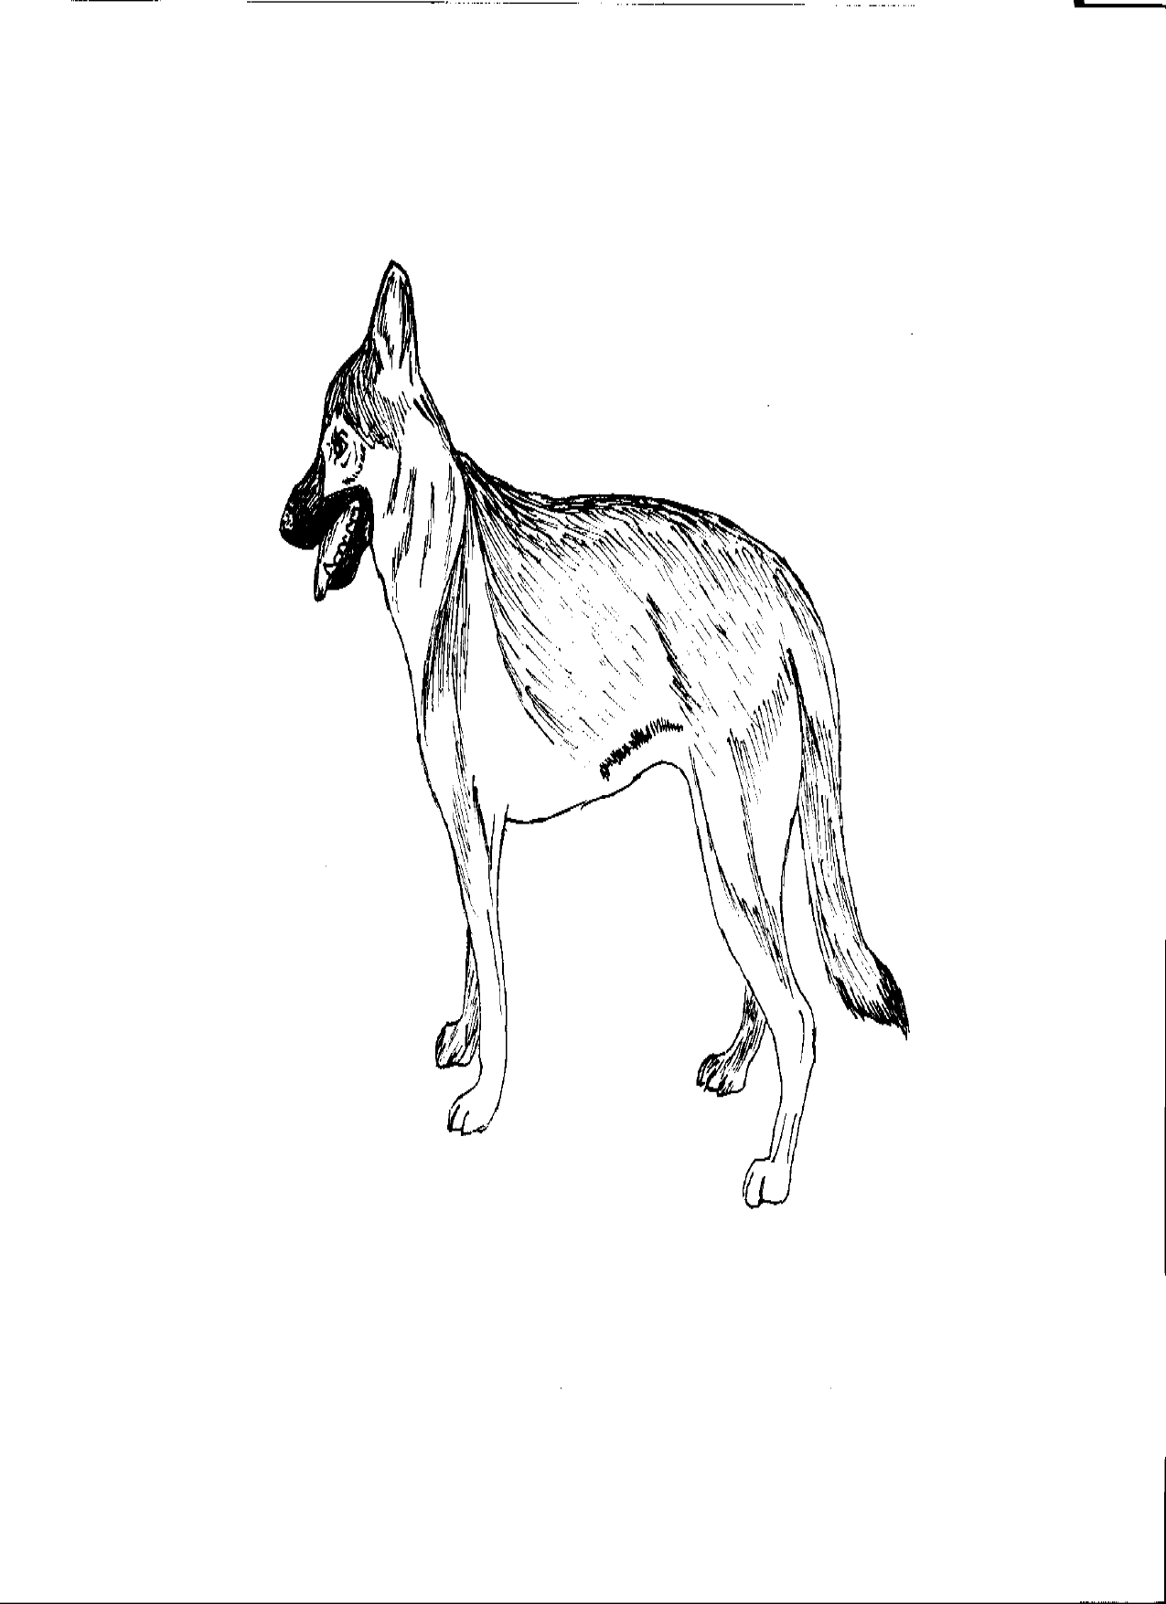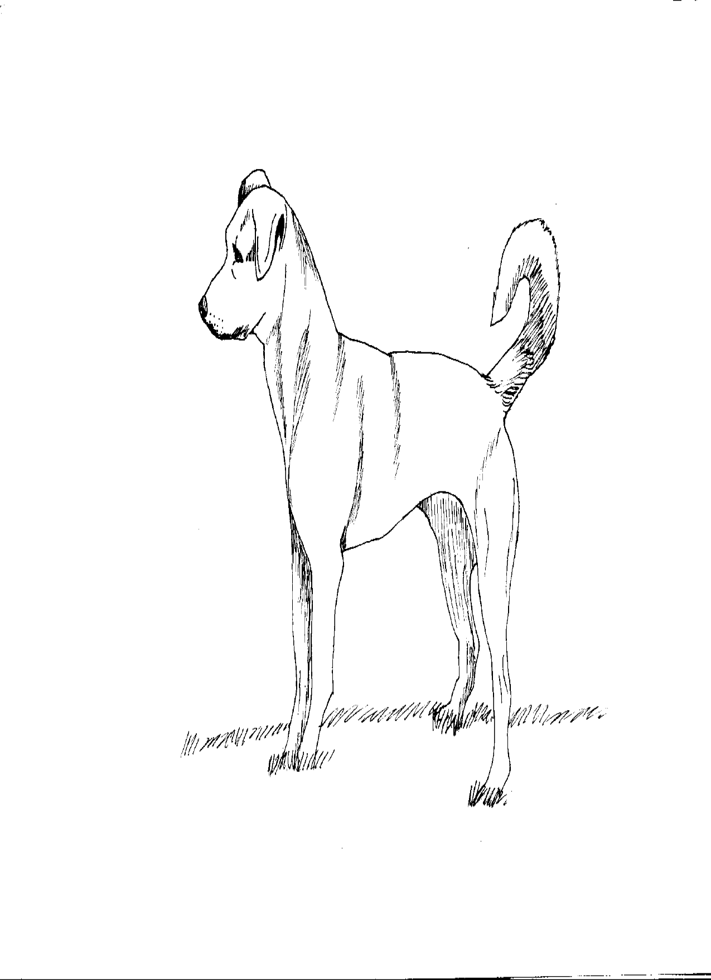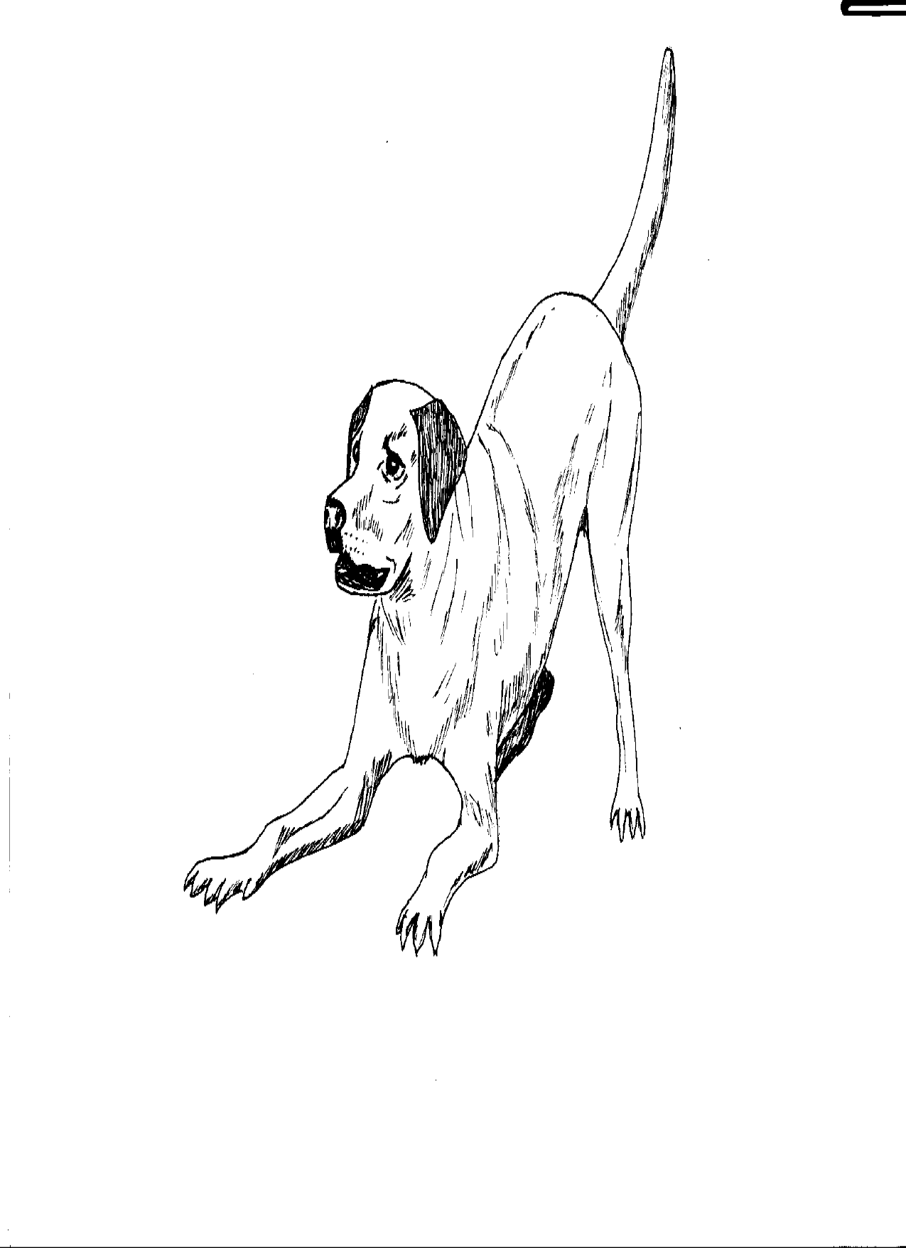
a
c
b
d

Figure 2

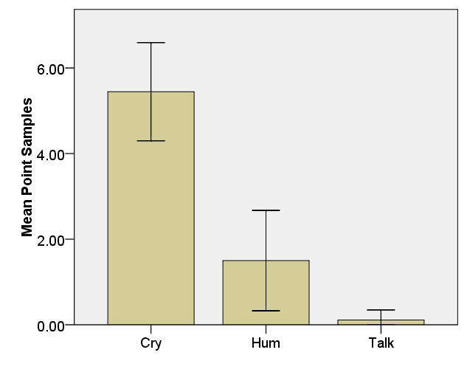
Figure 3

