i-LEGEND - An interactive city legend
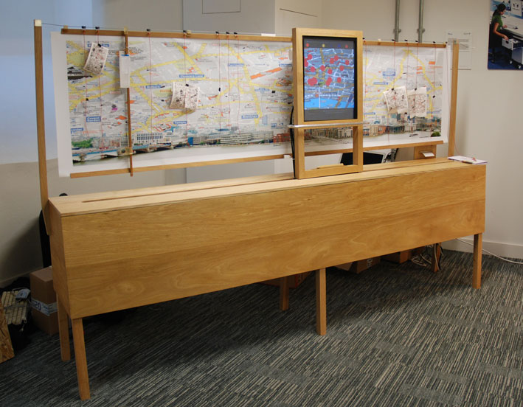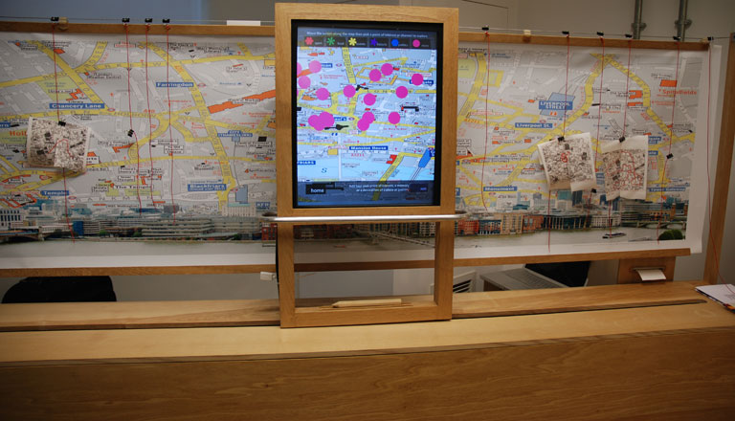
This project is focused on the city map and legend. This project and, indeed this prototype, has been addressed to exploring the possibilities of extending the experiences and performances of, and with public maps and city legends; making ‘media’ related to locations within the map/legend accessible and evident to a user/viewer.
The traditional city legend is usually located at a vantage point where there is a ‘vista’ in which key features of the city are visible. Through map or city outline/silhouette, arrows and identification labels, the legend allows a viewer to appreciate key features of the view in front of them.
In this project we have made experiments to see how we may enhance the legend by drawing different media transmissions into the legend/map and thus into the view.
We looked at the way these typologies – map and legend (in public spaces) - could be enhanced through ‘mediatisation’. In the interactive city legend we sought to draw different ‘content’, live and dead, published by institutions and individuals, related to, and connected in the legend/map to locations, into the legend/map. We also designed a related map that can be tagged with data glyphs that may be recorded/read with a mobile phone and draw down related content. These maps (paper) can be linked to the content of the legend.
The i- legend allows one to explore the relationship and connection between the different kinds of ‘media-content’ that can be drawn into the legend/map. Bringing together content from different sources and making them visible at the same time allows for different perspectives (sic) and readings of a place to be seen at once. For example one may draw up a twitter feed from someone at a particular place and at the same time access the ‘diary entry’ of someone that was there two months previously and have access to other histories and present and future events in that location. We are in these juxtapositions exploring the different ways one can approach and inflect readings of place through the ‘mediation of media’.
We are also exploring different ways one (users) can direct readings of the city. So for instance one may read diachronously (read a place historically - through time (e.g. what is happening in a city place now (4th June 2010), what happened yesterday and indeed 20 years ago) or synchronously - explore a multiplicity of spaces as they appear in the same period of time (e.g. what happened across the city of London on the day of Diana’s death).
The devices clearly present new opportunities for the construction and authorship of the view. The view of the device is in some way given over to a fragmented and democratized authorship. There are different involvements in the ‘authoring’ of the view – the many that ‘capture’ the view, and the many that select and compose the view. The way these two involved ‘authorial communities’ engage with each other and then with the ‘content’ of the view – not only the architectonics and topography of the city, but, also, the social formations and cultural spaces of the city - presents opportunities for exploring and building new connections through the view. The way consumers and producers of the view, and those communities in view for that matter, may bond through, real and constructed, identities, interests and narratives presents a new complex of connections that extend our current idea of communality and community in regard to the view. We may also explore community through time, as we are not only dealing with the current communities in view we are also potentially discussing communities of London from the past and future.
The representation of communities within the view and different communities construction of the view presents an ethical problematic. How do we present opportunity for the polyscopic and polyvocal engagement of the city without one view or set of views conflicting with others in unseemly ways. In the continuing development of the i-Legend we will need to take on this problematic and find a way of designing metadata sensitive to the multiplicity in the view and multiple viewpoints.

Exhibited in
‘MAKEBELIEVE’ Exhibition in the London Design Festival – 19 - 27 September, 2009 at Kinnarps, Dryden Street, Covent Garden, London
(http://www.londondesignfestival.com/events/goldsmiths-make-believe)
The ‘Mediating Place’ group (one of the five groups in the Leverhulme funded Spaces Of Media Research Programme) exhibited two prototypes in this exhibition - described as ‘an exciting and innovative showcase of emerging design talent from Goldsmiths, University of London’.
In the ‘Mediating Place’ project we are designing propositional objects; objects which propose new practices in media production (and reception). These propositional objects (props) aim to re-programme spaces in the city (the performativity of the spaces) by using an assemblage of different technologies to locate, dislocating and relocate ‘media’ in the city. These props are intended to make apparent possible future engagements, practices and experiences educed in these assemblages of technologies.

