Creative approaches to information literacy for creative arts students
Background and introduction
This paper will explore some of the issues and practices around general teaching and learning approaches within an arts education and how the Library Services department at the University of the Arts London (UAL) have adapted and collaborated with curriculum and other support areas in order to ensure that the information literacy user education and training is fit for purpose for this exclusive art and design environment. In achieving this the paper will introduce some specific concepts such as object based learning and radical information literacy, which have been used to inform an ever developing information literacy practice at UAL. These theories will be expanded upon during the course of the article, which will also use three case studies in order to link the theory into practice.
UAL is a large university specialising in creative arts higher education and research. It is the largest university in Europe to specialise in art and design, and is dispersed across London through its six high profile colleges: Camberwell College of Arts; Central Saint Martins; Chelsea College of Arts; London College of Communication; London College of Fashion; Wimbledon College of Arts
UAL has approximately 19,000 students studying on a range of art, design, fashion, media and performance programmes. This includes a high profile ‘Foundation’ programme as well as a large portfolio of taught undergraduate and postgraduate courses. This provision attracts students from all over the world resulting in a very high proportion of international students (49% in 2015). UAL also has a very strong research profile within the arts disciplines and has a number of active researchers and doctoral candidates.
Teaching and learning in arts education
UAL can be regarded as a monotechnic, predominantly delivering art and design oriented programmes and research projects. Whilst the portfolio offered includes a diversity of subjects including curation, journalism, science and management courses, there is an ever present focus on the ‘visual’ even in the subjects which can be regarded as science or social science disciplines (i.e. fashion management, applied psychology, conservation, etc.) As a specialised arts institution teaching and learning activity presents certain challenges, largely because of the ‘creative’ nature of the majority of its programmes. This has an impact on curriculum design, particularly in respect of accommodating learning styles, writing learning outcomes and assessment activity. In discussing learning styles in relation to information literacy teaching Blanchett, Powis and Webb (2012, p.19) suggest that learning styles theories are linked to discussions of personality and individual difference, including theories of multiple intelligence (e.g. musical or artistic intelligence). They also highlight that critics of learning styles theory suggest that there is limited evidence of their actual impact. This is difficult to justify in an arts education environment where visual and kinaesthetic learning styles have proved to be dominant. Whilst it is important not to stereotype arts students and practitioners to these specific learning styles there is evidence to suggest that they need to be taken into account. In establishing his Learning Styles Index, Kolb suggests that those who specialise in the arts tend to be divergers “focusing on reflective observation and having the ability to view concrete situations from many perspectives and to organise relationships in in a meaningful ‘gestalt’” (Kolb, 1980, pp. 237 – 238). A later study in which higher education in a management institution and an arts institution and were compared found substantial differences in how experiential learning took place in the two environments: where management education focused on telling, art education focused on showing; management education emphasised theory, art education emphasised theory into practice; art education focused on the learners’ inside-out expression, management education on the learners’ outside-in impression. The study also found an acceptance of individual learning and diversity of approach within arts education as opposed to the more didactic instructional approach for the management education (Kolb & Kolb, 2005). Whilst critics might suggest that it cannot be definitely argued that particular disciplines have exclusive learning styles, studies such as these present compelling evidence that there are clear differences between disciplines and this needs to be taken into account in a monotechnic arts education environment.
This in turn has an impact on how effective assessment and learning outcomes are achieved in art and design programmes. Davies (2000) addresses some of the challenges that this poses and discusses how the dominant learning styles of arts students lead to “the more complex cognitive abilities which are particular to art and design such as creativity, imagination and originality” (Davies, 2000, p. 5). He goes on to suggest that traditional learning outcomes rely on students’ convergent thinking (solving problems that have a unique answer) but that creativity, imagination and originality can only be surfaced through divergent thinking. “Divergent thinking is to do with generating alternatives, where the notion of ‘correct’ gives way to the broader assessments of value such as creativity, imagination and originality.” (Biggs, 1999)

Library Services and information literacy provision at UAL
Library Services at UAL is a centrally managed service and operates across all six colleges, offering a consistent library experience in each. Unlike other university libraries, academic liaison is not a centrally managed function, nor is it the specific activity of a dedicated ‘liaison librarian’ role. Because of the dispersed nature of the UAL college libraries there is a local management structure at each and within each college library team are a number of ‘academic support librarians’ whose job roles include elements of academic liaison (and induction and information literacy delivery) as well as collection development and customer service activity. Library Services sits within a wider Library Services and Academic Support directorate. Within this directorate, there is a central Library Services steering group, with representatives from each college library, which leads on library academic support activity and this includes the provision of a service-wide information literacy framework. The UAL Library Services information literacy framework is used to establish and define a core and minimum induction and information literacy offer (dependent on academic level) but the actual nature and style of individual sessions is determined on a local basis. Additional sessions and workshops are offered as part of a central, university-wide academic support programme. Embedding Library Services’ academic support activity within the wider institutional and college level academic support activity in this way, provides an advantageous model for students. “This distinctive offer seeks to enhance the students’ own learning abilities, strategies and knowledge that underpin progress achievement and future success in an anticipatory and innovative manner. Sessions are often co-created and co-delivered (...) so that students benefit from the differing expertise of the staff involved.” (Christie, 2015, p. 52).
The overall support structure at UAL means that there are many library staff involved in academic liaison and the provision of academic support and strong relationships have developed across all curriculum areas. Academic support librarians are very much part of their course / subject areas’ academic teams which enables research and information skills teaching and training to be embedded into both the design and delivery of curriculum programmes, from unit level to degree and above.
There is an emerging concept within the information literacy literature available that information literacy practice for art and design students needs to be ‘different’. Whilst ‘different’ in this context might be difficult to define, the discourse suggests that some traditional approaches to teaching information literacy and indeed other literacies (which might be applied in multi-disciplinary or polytechnic higher education institutions) cannot be applied in the art and design environment, due to a number of factors. Some research suggests that the focus of information literacy in art and design environment is on teaching rather than embedding such instruction in an integrated way into a curriculum or programme, so that it is relevant to art students at the point of need (Walczak, Reuter & Sammet, 2009). Similarly, there is evidence that an integrated programmed approach, which introduces information literacy concepts throughout the curriculum is the most effective way to inspire studio based art students to use appropriate resources (Greer, 2015). Bennett argues that “two of the most difficult groups of students to draw into the library are the studio art and architecture students” (Bennett, 2006, p. 38) She goes onto to suggest that this is because these students do not regard the library as logically fitting into their studio projects and studio based learning. This problem therefore lends itself to developing a more creative approach to teaching information literacy and considering how the ‘studio’ can be brought into the library. Another ‘different’ approach that is acknowledged within the teaching information literacy in the art classroom (or studio) is the action research approach, which approaches teaching from an inquiry point of view and allows ideas to develop. Zanin-Yost and Tapely (2008) suggest that the art library is an ideal place for action research to take place in that it can provide resources to stimulate and inspire practice (e.g. reference books, images, artefacts, artists’ books, artists’ biographies, poetry, etc.) This use of action research or enquiry based learning sits neatly with the visual and sensory ‘object’ oriented teaching and learning which dominates art and design institutions. Indeed, for many art and design libraries, the printed monographic and periodical stock, alongside their special collections and archives are far more than just vehicles for information and knowledge, but are artefacts in themselves used to inspire creative practice (Carden, 2016). The ability to interpret visual images is all important in arts education and cognitive visual literacy is increasingly becoming a vital part of information skills training for art and design students (Beatty, 2013)
Radical information literacy
Arts education lends itself to specific learning styles and this means that differentiation is a key consideration when planning teaching and learning activities. For the librarians at UAL this means embracing the ‘differences’ in approaches to teaching information literacy, as identified above, and collaborating with academic colleagues to be creative and innovative in their approaches to designing and delivering information literacy programmes. Whitworth (2014) critiques and questions many aspects of what can now be regarded as traditional information literacy practice in his own theoretical perspective in his book “Radical information literacy”. As a theoretical framework, radical information literacy really resonates with current practices at UAL. Whitworth argues for a dialogic approach to information literacy, where collaboration and discussion is fundamental in creating an information landscape. Lloyd (2010, p. 2) describes such an information landscape as “the communicative spaces that are created by people who co-participate in a field of practice”. It can be argued that academic support librarians at UAL are operating in such an environment and contributing to the development of the information landscapes in which they are working. Lloyd goes on to suggest that for a learner to become information literate they need to be self-aware and experience information through the opportunities provided to them through the information landscape they are in. This is quite different to learning information literacy skills through traditional methods. Whitworth also discusses the importance of the ‘artefact’ within the information landscape suggesting that artefacts come in many forms and “are the products of cognition and collaboration, and through interaction with them, further insights are formed” (Whitworth, 2014, p. 17). Whitworth offers some examples of artefacts as: particular ways of thinking; or the result of a process of intellectual enquiry. It is through artefacts that cognitive authority can be scrutinised, which is a further underlying principle of radical information literacy. A final aspect of Whitworth’s framework, which is pertinent at UAL is that of ‘phenomenology’ which is accepting of different ways of looking at things and allows for a “multiplicity of personal constructs, perceptions and actions which influence communication” (Whitworth, 2014, p. 63). Hicks and Sinkinson (2015) also discuss the growing complexities of information landscapes and argue that they are marked by participation and the learner’s contributions and expressions, prior knowledge and new experiences which all contribute to the learning. They point out that “static, imposed [learning] frameworks designed to manage inquiry and information and no longer viable solutions and that instead a model of learning that is learner centred has to be adaptable and flexible and more personally meaningful in the face of changing landscapes”(Hicks and Sinkinson, 2015, pp. 6-7). Although a very brief overview of some of the facets of radical information literacy, this provides a useful theoretical framework on which to illustrate some of the recent developments and practices at UAL.

Practice based research and object based learning
As well as teaching, learning and research, one of the other student focused activities which is prominent at UAL is that of ‘making’ or ‘creating’, with many courses having physical creation of art and objects at the centre of the curriculum. Traditionally the ‘studio’ has been the place where ‘making’ is carried out but in an institution which occupies itself exclusively with arts education ‘maker spaces’ can develop in a number of areas which means that both the notional and physical boundaries between teaching, learning, research and making become less clear. The structure and practice of academic support at UAL contribute to the development of information landscapes and encourage the divergent thinking that Davies (2000, p. 5) references above.
Two key features of higher level arts education which are present within UAL’s information landscapes are practice based research and object based learning. As a visual and physical discipline arts education lends itself very well to the concept of practice based research and academic staff often inform their teaching through their practice and their research. This approach means that in an arts higher education environment there is often little demarcation between where the classroom stops and the studio starts. Such an environment also allows for a similar transition between the studio and the library facilities and such a continuum allows for creative approaches to delivering library services, particularly when it comes to library and information instruction. In particular students at UAL have responded well to object based learning (OBL) as a technique to develop research and critical enquiry skills. OBL uses objects to inspire discussion, group work and lateral thinking (Chaterjee, 2009, p. 179) Ultimately OBL uses objects to provoke thoughts and discussion, to encourage difference perceptions and divergent thinking. Grounded in museum based pedagogy OBL is often used to teach verbal, critical and visual literacies (Schwartz, 2008) and as such is seen as versatile practice to accomplish the discussion of multi-literacies. Hardie (2015) discusses how objects are used to facilitate learning and “how artefacts can surprise, intrigue and absorb learners; how learners’ wonder at or pleasure in, an object. The ‘wow’ of an item can create rich, important and fun learning.” (Hardie, 2015, p. 4). Through engaging with and analysing objects which provoke discussion and reflection, learners develop both visual literacy and critical information skills whilst engaging in active learning.
UAL has embraced OBL as an innovative means through which to teach, and to inspire students to critically enquire and develop awareness of their own learning. The following case studies will illustrate some of the ways which UAL Library Services have taken information literacy teaching well beyond the library and have recently introduced practice based and OBL approaches to increase student attendance and perception of usefulness and relevance, in addition to their intrinsic benefits (new skills, transferable knowledge, etc.) Preliminary data (feedback forms, attendance data, anecdotal evidence) from several of the studies confirm these positive effects.
Success in these areas are due in part to the fact that UAL has a wide range of more than 150 archives and special collections which reflect the history and specialisms of the six constituent colleges. The special collections are varied and range from collection of artists' books to the Stanley Kubrick Archive, including manuscripts, printed books, ephemera, prints, posters, artworks, photographs, personal and organisational archives, correspondence, moving image, digital material and technical equipment. These resources, based at the college libraries and the UAL Archives and Special Collections Centre, are key parts of both research and teaching infrastructures and used in a large range of research, learning and teaching activities, internally and externally. They support academic and creative work, integrating practice and research, from Foundation to PhD level.
Special collections are used in course inductions, in themed seminars tied in with course briefs or projects, and as integrated taught elements part of course curriculum. Independent learning and research is also supported with drop-in sessions and one-to-one sessions by appointment, and individual invigilated use in the library. In many instances the use of these collections in the delivery of information literacy training is developed and delivered in collaboration with curriculum based academic colleagues and study skills tutors (UAL, 2013)
Some of the collaborations and creative approaches to information skills training now in place at UAL are described in the three case studies that follow:
Case study 1: Drawing inductions
This case study is based on recent developments in the induction programme for students of the Foundation Diploma in Art and Design course, implemented at Camberwell College of Arts Library, with the aim to improve attendance, integration within the programme and perception of the library and its services. The library induction is essentially the students’ introduction to the college library. Two key aspects of the new inductions were use of practice-based activities (drawing) and peer to peer learning, to help students feel more comfortable and engaged.
Camberwell College of Arts offers one of the two Foundation Diploma in Art and Design courses delivered at UAL. Foundation is a year-long course where students considering practice-based undergraduate study explore art and design disciplines, experiment with materials, methods and approaches, and build a portfolio.
The Foundation Diploma course at Camberwell gives students a chance to explore different disciplines in Art (Drawing, Painting, Photography, Time-Based Media, Sculpture), Communication (Film and Animation, Graphic Design, Illustration) and Design (Design for Performance, Theatre, Stage and Screen; 3D, Product and Spatial Design). There are approximately 600 students enrolled onto the course each year and the majority of students are 18/19 year olds that have come straight from school. For the past four years, the course has been taught in its own dedicated site, a 15 minute walk away from the main Camberwell College of Arts building and the library. Foundation students’ use of the library significantly decreased after moving to its current satellite location, as it was perceived as being remote from where their studios and teaching spaces were located.
The library has a strong relationship with the course and its staff, built up over many years, with a dedicated librarian, responsible for day to day liaison services and resource provision for the course, and who attends Board of Studies meetings as well as other course related events in order to achieve this. A library development session for Foundation course academic and support staff took place in June 2014, to discuss changes to the library induction programme and to generate ideas on how best to increase use of the library by Foundation students. From this collaboration came the development of a ‘Library’ section in the wider course structure, specifically the student log books (a journal/sketchbook they are required to keep as part of their course)
A central part of this development was to identify the intended learning outcomes for the students attending the library induction sessions. Library and course staff wanted the induction to be an interactive and creative process that students would want to engage with, deliberately broad enough to encourage exploration and possible to execute with 600 students and small team of staff. By approaching the library as a specific information landscape and encouraging the students to engage in this through activity and discussion the library staff were effectively applying a radical information literacy approach to their induction process. A key aspiration was to encourage students to return and use the library to conduct research regularly during their course therefore a new task to be carried out during the library induction was devised, in addition to the use of the student log books:
“Make a drawing of something that catches your eye or inspires you. It could be the physical space of the library, an image or idea from a book or periodical.”
As an added incentive drawings were to be entered into a competition to win a prize (librarians from the team volunteered to e-mail galleries/museums to source free tickets) and a selection displayed in the library. By introducing this drawing activity into the library induction, the library team were encouraging students to ‘create’ and collaborate as a means of enquiry, both fundamental elements of Whitworth’s radical information literacy. The Foundation students found this drawing activity to be very relevant and useful to them and it encouraged individuals and groups of students to form a proactive relationship with the library right from the beginning of their course. 550 drawings were entered into the competition and exhibited in the library, with images also uploaded to the Virtual Learning Environment (Moodle).
Student attendance was positive with 76% of students enrolled participating in the induction activity. Feedback about the induction sessions and activities was very positive, with more than 99% of the feedback rating it as “useful” or “very useful”. Written comments about the induction included:
“I didn’t know there were so many things in the library. I really liked sketching in there.”
“Very helpful explaining step by step of how to use online resources”
“It was great to be able to do some drawing as a way to learn about the library”
Since the introduction of this new induction project there has been a significant increase in the general use of Camberwell College of Arts library by Foundation students. This is evidenced in the current usage statistics and the significant increase of Foundation students’ book loans and renewals. For example, in the first year there were 2,080 loans/renewals during the first two months of the course (September and October 2014) as opposed to 588 transactions for the same period the previous year. Library visits have also increased significantly (35,201 visitors autumn term 2014/15 as compared to 28,564 visits for the same period the previous year)
As a result of engaging the Foundation students through this creative approach to introducing them to the library, the students are making increased use of the facilities and resources available to them throughout their short year long course.
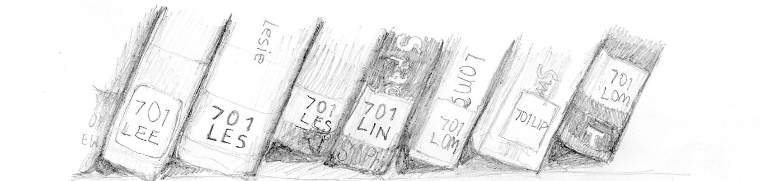
[Figure 1. Example of student drawing. Image credit: Ladina Clement]
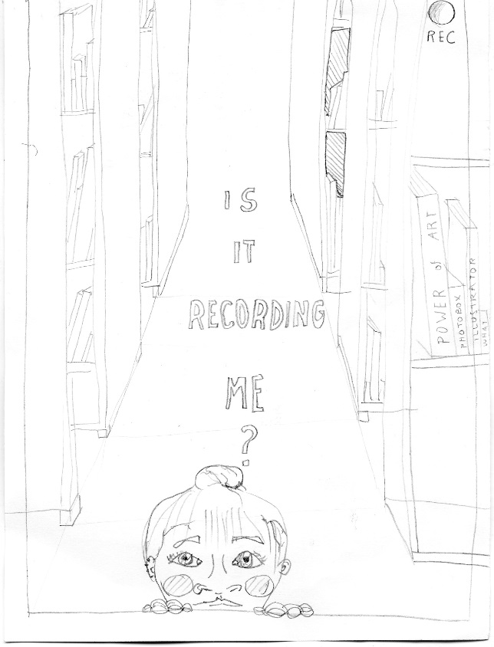
[Figure 2 Example of student drawing. Image credit: Marta Raimundo]
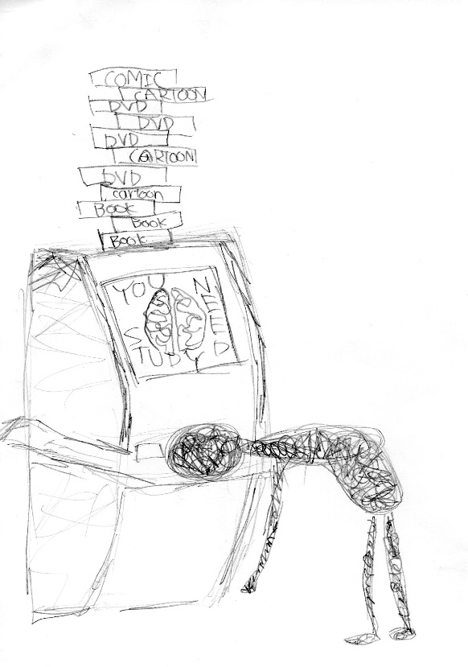
[Figure 3 Example of student drawing. Image credit: Shiwa Tokuoka]
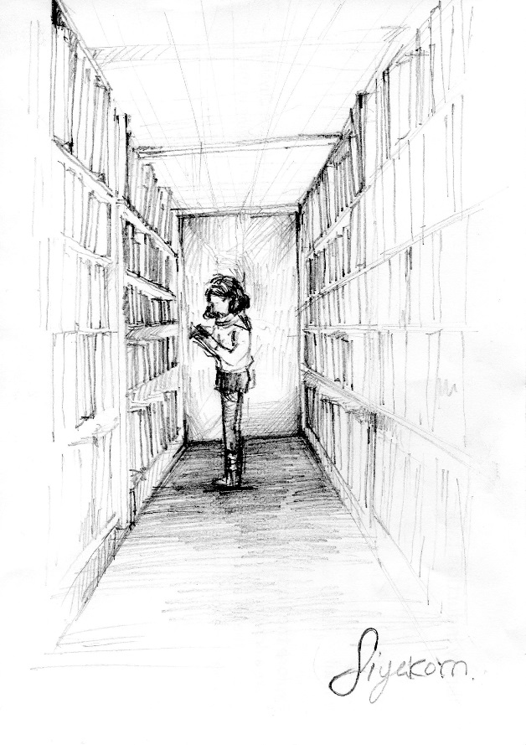
[Figure 4 Example of student drawing. Image credit: Siyakorn Kimhasawad]

Case study 2: Unpacking Barbie
The next case study illustrates an innovative collaboration between librarians at London College of Fashion (LCF) and colleagues in the academic support team in developing a resources based and object based learning workshop designed especially for widening participation students and with specific learning outcomes to do with developing critical thinking, questioning and research skills at the heart of it. The workshop was developed as part of the ‘Make it at LCF’ programme, which is run for students from widening participation backgrounds across a range of courses during the summer before they embark upon their programme of study in the autumn term. Led by an academic support lecturer, who specialised in supporting widening participation students, the workshop entitled ‘Unpacking Barbie’ was developed in order to encourage students to engage with wider concepts linked to cultural and historical studies. The workshop is designed to explore and develop research skills, with a particular focus on the library, its resources and the support available from library staff.
The academic support team at LCF had observed that their widening participation students found it difficult formulate their thoughts and ideas into relevant questions and to understand how to contextualise images and objects. The students also found the idea of questioning something or someone as problematic and had real difficulty in questioning and challenging information, ideas and theories presented to them. The academic support team’s challenge was to find a teaching solution which would address both the development of critical thinking skills and also visual literacy skills in their students. Appropriate learning outcomes were established, and the resulting workshop was developed and delivered in collaboration with the subject librarians at LCF and the library was used as the setting for the resource and object based learning session to take place in. The object in question was that of the Barbie doll, a large collection of which was used to demystify theory. Learning academic skills through plastic dolls might seem a surprising combination, but LCF staff had already found that using familiar objects really helps to support students whilst they are dealing with unfamiliar and challenging concepts. Handling real objects helps to promote interest and understanding as students interrogate the objects, developing critical enquiry skills through the use of artefacts within their information landscape. Dolls are common in most cultures and can evoke powerful emotions and memories. The tactile nature of this skills session particularly resonates with students who create and work with physical objects. Through considering the physical appearance of Barbie students develop ideas of gender, feminism, the changing roles of women, uniform, body image, race, branding, queer culture and cosmetic surgery. Relevant resources were located and used in the workshop (e.g. books, journals, articles and films dealing with Barbie and her existence in 21st century Western culture as well as items about feminist theory and material culture). The workshop also relies upon an element of ‘story telling’ and both librarians and academic support lecturers share their stories about Barbie. The stories are insightful, humorous and quirky and are personal recollections from the staff facilitating the session as they are asked to question each other about Barbie in front of the students. Meanwhile the students are handling Barbie dolls and are surrounded by the above mentioned resources. This whole experience allows the students to see that questioning (anything) is normal and acceptable and all participants (students and facilitators) end up ‘thinking out loud’ and scrutinising Barbie together. Another objective of this activity is for the students to see the library staff differently, as staff who work collaboratively with academic support, who input into curriculum and who have real life stories to share about their subject matter. This collaborative approach to delivering academic skills sessions works on a number of levels not least through the variety of learning techniques which can be applied including cognitive, affective, emotional and kinaesthetic learning. Seeing the library staff working so closely alongside curriculum based staff also adds value to this mode of delivery instils a greater degree of confidence in the student and this can help in alleviating any anxiety they have about the library.
Questioning is at the heart of becoming an independent learner and as well as being introduced to the practice of questioning and critical enquiry, students are then asked to use the resources available to find two surprising facts and two shocking facts about Barbie, that they previously were not aware of. ‘Unpacking Barbie’ uses the Barbie dolls as objects alongside the wealth of library resources available to contextualise the learning taking place. Barbie (the doll and the scholarship) contains many topical, cultural, historical and personal references that students can ‘unpack’ and discuss, and in doing so offers a clear peer-learning opportunity and a safe learning environment in which students can develop the critical thinking, questioning and visual literacy skills which are the intended outcomes of the session. This example of Object Based Learning in practice is a good example of ‘reflection in practice, as identified by Schön (1983) where students reflect, evaluate and take action through making decisions during the object handling activity. ‘Unpacking Barbie’ has been a resounding success for the LCF Library and Academic Support teams and is now in its third successive year of being run. It is always very well received by students, whose feedback suggests that as a result of taking part in the workshop, students certainly feel that they have acquired new research skills and talk fondly of the experience and how they have used the library and will continue to do so throughout their studies.

[Figure 5 Examples of objects in ‘Unpack Barbie’ session. Image credit: Leila Kassir]
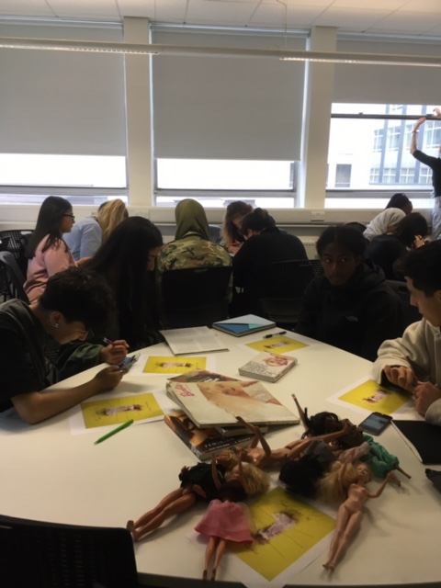
[Figure 6 Students in ‘Unpack Barbie’ session. Image credit: Abigail Jones]
Case study 3: Special Collections workshops
The third case study, focuses on the rethink and redesign of special collections inductions at Chelsea College of Arts Library to address issues of attendance, perception of usefulness and relevance, and integration of information literacy within course.
The special collections at Chelsea complement the main library collection and reflect its subject specialisms, with an emphasis on modern and contemporary art and includes artists' books, multiples, ephemera and archives. Special collections seminars (general introductions, or tailored to specific requirements: e.g. around the idea of appropriation) are arranged on demand by academic support librarians, supported as needed by other specialist library staff. Courses at Chelsea take advantage of this opportunity, as do other courses within University of the Arts London and there is interest also from external partners as well (undergraduate and postgraduate courses in fine art, printmaking, art history, medieval studies, writing, contemporary poetry, etc. (Grandal Montero, 2012)
Inductions, seminars, drop-in and other sessions (group and individual) are monitored for quality and relevance by using feedback forms. The results are very positive overall and emphasise the importance of the direct interaction with Special Collections material and staff, and the engagement at intellectual, physical and emotional levels that comes from this. Every year more than 90% respond ‘Very Helpful’ / ‘Helpful’ to the question ‘How useful was today’s session?’. Similarly 90% of completed surveys respond affirmatively to the question ‘Will the session be helpful for your studies?’ Examples of other feedback for the Chelsea Special Collections sessions include:
“I found it very useful and has given me lots of ideas and a different way of working”
“It was amazing because I didn’t know there were such collections which will really help me in my research: I’m determined to use this source for my studies”
“Very helpful and inspiring for my practice”
“Beyond informative. Interesting and enjoyable in many ways”
In 2014/15 changes in the BA Fine Art course, alongside some of the feedback and comments from students and staff on their induction to the Special Collections prompted a re-evaluation of the format and purpose of these sessions, and the development of a new approach, as part of a collaborative process involving library and academic staff. In the past, all new students at Chelsea, including BA Fine Art, had been offered a 45 to 60 minutes induction to the materials kept as part of the Special Collections, in groups of up to 15 students to allow handling and interaction with the material. This is an important element of the library induction programme that prepares the student to use these important resources in their academic research as well as in their artistic practice. Attendance at these inductions for this course in recent years had declined to a relatively low level (around 50%) and, although the majority of the feedback had been positive, a number of concerns and criticisms had been raised (e.g. very general nature of the sessions, the large amount of inductions delivered at the same time early in the year, etc.) A key new factor that necessitated changes to be made was the expansion in student numbers, reaching numbers not sustainable under the existing induction model (e.g. more than 120 students per cohort).
A series of new “workshops” (rather than “inductions”) were developed. The workshops were not compulsory for students, but they were encouraged to attend and they ran every Friday morning for 4 weeks per term. The workshops are thematic, related to course content and key areas of contemporary practice chosen with academic staff, designed to showcase different aspects of the library collections but also to appeal to students. The four different workshops, initially launched were: Text in contemporary art practices; Photographs and photobooks; Appropriation, reference and repetition; and, Artists' publications in Asia. The material for the sessions was drawn from the same collections that were previously highlighted in the induction session at Chelsea (e.g. artists' books, multiples and archives) but presented in a different context, driven by a thematic narrative, rather than a library skills one. This way the theme draws the students’ interest while they can then discover other areas of the collection which might also be relevant/inspire them. As with other sessions using Special Collections items, Object Based Learning ideas underpin their design and delivery, and having the chance to see and handle the material makes their interaction richer and more memorable for the students. There was a high take up of attendance, with some sessions oversubscribed. Feedback forms gave 100% for usefulness, and some of the comments included:
“It was awesome!”
“Amazing collection! I'll definitely make the most use of the resources. Also the librarian was very knowledgeable and helpful!”
“Really interesting. Made me aware as to what is available”
To avoid “induction fatigue”, further workshops were introduced later in the year (in the spring and summer terms), with some re-runs of earlier ones: Performance; Maps and diaries; Concrete Poetry and experimental literature by artists; Collaboration and collective works; Artists' books and the digital; Ephemera and mail art.
The total attendance for the first year of the new workshops was 61%, a significant improvement on previous year’s figures, with 100% students finding the workshop “useful” or “very useful”. The programme of workshops has been another success in the Library Services approach to delivering information literacy training and will continue to be refined and further developed in respect of the feedback received and will aim to increase attendance and the perception of usefulness and relevance of such training.
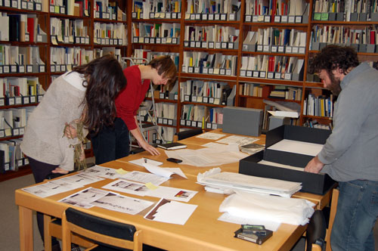
[Figure 7 Chelsea College of Arts students and staff participating in special collections session. Image credit: Chelsea College of Arts Library]

Conclussion
Responsiveness to academic and student feedback about library inductions and workshops is essential to high levels of attendance and perceived usefulness/relevance. The sessions described in the case studies presented in this article demonstrate this and utilise collaborative, peer to peer learning that helps students feel more comfortable with libraries within their specific ‘arts based’ information landscapes. Critical enquiry, reflection and discussion is encouraged through the practice-based and Object Based Learning initiatives and other innovative library activities that attract them, reinforcing the relevance of our collections and services to their practice. These initiatives also provide us with a way to engage creative arts students further in more traditional information skills sessions (e.g. e-resources, referencing, etc.)
The case studies demonstrate how UAL librarians are empowered to be creative and innovative in their approach to delivering (radical) information literacy training and are encouraged to collaborate with academic colleagues and academic support colleagues. In doing so the service has been able to be more responsive to specific student needs and sessions have been developed and targeted for particular cohorts of students, addressing ‘real’ information literacy objectives required for their programmes of study. All the groups of staff mentioned have worked effectively and collaboratively to integrate and embed library activities within courses, through curriculum design and delivery.
This initial discussion and reflection around the UAL case studies confirms that all these approaches increase both student attendance and perception of usefulness/relevance of library teaching and learning sessions, in addition to their specific benefits. As such, these initial findings suggest that through focusing on radical information literacy and the uniqueness of the information landscape afforded through an arts environment, and incorporating Enquiry Based and Object Based Learning activities, UAL’s art and design students become more engaged in library induction and information skills instruction. Such practice will continue to be applied by Library Services at UAL and will be extended to even more programmes within the creative arts and design curricula across the institution.

References
Beatty, N. (2013). Cognitive visual literacy: from theories and competencies to pedagogy. Art Documentation: Journal of the Art Libraries Society of North America, 32(1), 33-42.
Bennett, H. (2006). Bringing the studio into the library: addressing the research needs of studio art and architecture students. Art Documentation: Journal of the Art Libraries Society of North America, 25(1), 38-42.
Biggs, J. (1999). Teaching For Quality Learning at University. Buckingham : Open University Press.
Blanchett, H., Powis, C. & Webb, J. (2012). A Guide to Teaching Information Literacy: 101 Practical Tips. London : Facet.
Carden, K. (2016). The printed book is a very persistent thing. UKSG eNews, 379. Retrieved 10th September 2016 from: http://www.jisc-collections.ac.uk/UKSG/379/The-printed-book-is-a-very-persistent-thing/?n=121b8a3f-e721-4bc0-8354-7ad4d47f99de
Chatterjee, H. (2010). Object-based learning in higher education: the pedagogical power of museums, p.179-182. In Putting University Collections to Work in Teaching and Research – Proceedings of the 9th Conference of the International Committee of ICOM for University Museums and Collections (UMAC), 10th–13th September 2009. Berkley : ICOM.
Chatterjee. H. J., & Hannan, L. (2015). Engaging the Senses: Object-based Learning in Higher Education. Farnham : Ashgate.
Christie, P. (2015). Re-visioning academic support as an innovative and inclusive offer for creative arts students. SCONUL Focus, 64, 51-56
Davies, A. (2000). Effective Assessment in Art and Design: Writing Learning Outcomes and Assessment Criteria in Art and Design. Project Report, Centre for Learning and Teaching in Art and Design, University of the Arts, London. Retrieved 10th September 2016 from http:///ualresearchonline.arts.ac.uk/629/
Grandal Montero, G. (2012). Artists' books in HE teaching and learning. The Blue Notebook,7(1), 36-43.
Greer, K. (2015). Connecting inspiration with information: studio art students and information literacy instruction. Communications in Information Literacy, 9(1), 83-94.
Hardie, K. (2015). Wow: the Power of Objects in Object-Based Learning and Teaching. York : Higher Education Academy. Retrieved 10th January 2017 from https://www.heacademy.ac.uk/system/files/kirsten_hardie_final.pdf
Hicks, A. & Sinkinson, C. (2015). Critical connections: personal learning environments and information literacy, Research in Learning Technology, 23, 1-12. DOI: http://dx.doi.org/10.3402/rlt.v23.21193
Kolb, A. & Kolb, D. (2005). Learning styles and learning spaces: enhancing experiential learning in higher education. Academy of Management Learning and Education, 4(2), 193-212. DOI: 10.5465/AMLE.2005.17268566
Kolb, D. (1980). Learning styles and disciplinary differences. In A. Chickering (ed.) The Modern American College: Responding to the New Realities of Diverse Students and a Changing Society. San Francisco : Jossey-Bass, 232 – 255.
Lloyd, A. (2010). Information Literacy Landscapes: Information Literacy in Education, Workplace and Everyday Contexts. Oxford : Chandos.
Schön, D. (1983). The Reflective Practitioner: How Professionals Think in Action. London : Temple Smith
University of the Arts London (2013) Academic Use of Archives, Museum and Special Collections 2009-2013. Retrieved 10th September 2016 from: http://www.arts.ac.uk/media/arts/study-at-ual/library-services/documents/ArchivesSpecialCollectionsReport.pdf
Walczac, D., Reuter, M. E. & Sammet, D. L. (2009). A program for introducing information literacy to applied art and design students. Communications in Information Literacy, 3(2), 193 - 203
Whitworth, A. (2014). Radical Information Literacy: Reclaiming the Political Heart of the IL Movement. London : Chandos.
Zanin-Yost, A. & Tapley, E. (2008). Learning in the art classroom: making the connection between research and art. Art Documentation: Journal of the Art Libraries Society of North America, 27(2), 40-45.

? http://www.arts.ac.uk/study-at-ual/library-services/collections-and-archives/archives-and-special-collections-centre/stanley-kubrick-archive/

