From Science Fiction to Science Fictioning: SF’s Traction on the Real
Simon O’Sullivan (Goldsmiths College, University of London)

The following article explores the different kinds of traction science fiction might have on the real and, in particular, attempts to define a kind of experimental writing practice (when this is broadly construed) that is less about the future than an instantiation of it. It begins with a commentary on Fredric Jameson and Raymond Williams, and their writings on utopia and sf, and then proceeds to Quentin Meillassoux’s concept of an ‘extro-science fiction’ – or fictions about worlds in which science is impossible – before proposing that formal experimentation (and especially the illogical sequencing of sentences and use of atypical syntax) serves to present these other space-times. Experimental sf does not so much describe future worlds as fiction them within this one, offering a concrete ‘non-literary’ counterpart to the utopian hopes of Jameson and Williams. The final section offers a case study of, what I will call, ‘science fictioning’: the experimental sf ‘novel’ (that is also a theoretical tract and visual art work) Cyberpositive (1996) by the art collective (or ‘collaborative artist’) known as o[rphan] d[rift>].

Science Fiction and Utopia
The cultural theorist, Raymond Williams, provides a compelling entry-point for thinking the relations between fiction and the future. In his essay on ‘Utopia and Science Fiction’ (1978), he lays out for both genres a matrix of narrative tropes: the positing of a paradise and/or hell; the externally altered world; the willed transformation; and technological transformation. For Williams, the first of these, typically found in fantasy literature (and in which the place is more determinate than the means of getting there), is predominantly a form of magical or religious thinking. In terms of Williams’ distinction upon the temporal make-up of the present into residual, dominant and emergent cultures (Williams 1980: 31-49), this trope tends to utilise archaic forms that are, as it were, already incorporated within the dominant culture. The second category is also of less interest to Williams amounting, as it does, to the positing of a transformation not caused by human actors (for example, by a natural catastrophe). As a Marxist, it is the third category that Williams is most interested in but, in terms of cultural diagnosis, it is also the fine line between the third and the fourth that commands his attention. The interest in willed transformation, which for Williams is a characteristic of properly utopian fictions, is that it attends to human agency. In such fictions the future is not simply portrayed as the result of technological progress divorced from human sociality. For Williams, humanity is the only real historical actor and, as such, the only progenitor of technological development. Although science fiction crosses all four categories, it is especially the fourth that characterises it in its typical form.
Following this matrix and his interest in agency, Williams suggests that the different kinds of fiction laid out above are also expressions of different class positions (with their own particular ideas – or fictions – about their relation to the dominant mode of production). It is here that he makes some compelling remarks about the kinds of utopia attached to a rising class as oppose to those associated with a descending one; either a systematic utopia (an expression of confidence) or one more open and heuristic (which, for Williams, expresses a lack of confidence). Williams goes further in his analysis, though, and foregrounds a very particular kind of utopian fiction that attends to the transition to a new kind of world and, with this, the development of ‘new social relations and kinds of feeling’ (Williams 1978: 209). Such literature is not just the dreaming of another place but reports on the struggle to bring this other world about. Williams’ paradigmatic example is William Morris’ News from Nowhere (1890) but he also cites a more recent case: Ursula Le Guin’s The Dispossessed (1974). For Williams, this particular novel of ‘voluntary deprivation’ is especially attuned to our present condition, in particular, the dissatisfactions that come with mass consumerism. As Williams remarks:
It is probably only to such a utopia that those who have known affluence and known with it social injustice and moral corruption can be summoned. It is not the last journey. In particular it is not the journey which all those still subject to direct exploitation, to avoidable poverty and disease, will imagine themselves making: a transformed this-world, of course with all the imagined and undertaken and fought-for modes of transformation. But it is where, within a capitalist dominance, and within the crisis of power and affluence which is also the crisis of war and waste, the utopian impulse now warily, self-questioningly, and setting its own limits, renews itself. (Williams 1978: 212)
As opposed to a writer like Fredric Jameson, whose own writing on sf is often a form of ideology critique, it seems to me that Williams is more attuned to the innovative and experimental aspects of the genre. Indeed, we might say that sf is a site of emergent culture and, as such, offers up the ‘new patterns of feeling’ (Williams 1988: 359) that he sees as characteristic of the genre. Although this might involve more technological predictions, for Williams, sf is at its best when it explores what Gilbert Simondon once called other ‘modes of existence’ (Simondon 2011). Sf can, in this sense, be an experimental social science – a ‘Space Anthropology’ – albeit one that is often un-tethered from the earth (Williams 1988: 359).
Jameson’s own idea of the traction of these future orientated visions in the present is, arguably, more deconstructive. The issue for Jameson is not just that sf is written in the present with the materials at hand, and therefore, necessarily, is limited by being a product of that present, but that this also represents a deeper ontological problem of how to combine ‘the not-yet-being of the future’ with the being of the present (Jameson 2005: xvi). Just as there are traces of the past in the present (hence, the ‘archaeology’ of Jameson’s title), so sf can offer traces of the future in the present. Yet, a key question remains as to the exact nature of this future trace; or, more generally, how something might be in the world but not wholly of that world. For both Jameson and Williams, this is the central dilemma in their understanding of sf: how to figure whatever is to come in terms of the already here or, at least, offer a view of a different kind of place in terms of the already visible.

Science Fiction and Extro-Science Fiction
The philosopher Quentin Meillassoux offers a compelling inflection on this problematic in his essay ‘Metaphysics and Extro-Science Fiction’ (2011). He suggests that whereas sf concerns itself with the relation of science to fiction and, in particular, the form that this science might take (Meillassoux’s definition of sf fits neatly into Williams’ fourth category of ‘technological determinism’), ‘extro-Science Fiction’ (which Meillassoux abbreviates to XSF) concerns itself with the possibility of worlds in which the very practice of science is impossible (and, as such, XSF may be said to accord with Williams’ characterisation of sf as ‘Space Anthropology’). To a certain extent these XSF worlds are chaotic and unpredictable, hence, the question of whether they are narratable and can be written as fictions at all in terms of plot or storyline. In relation to Jameson’s temporal and ontological paradox the issue becomes: is it possible to think – but also write – these XSF worlds from the perspective of our own world governed as it is by the laws of science and, indeed, inhabited by human subjects that are constituted by these laws (not least in the production of consciousness)?
Arguably, this forms part of a larger philosophical question about the possibility of thinking an ‘Outside’ to subjective experience. This Outside may also be the future, when understood not simply as the extension (and repetition) of already existing knowledges and logics (including science). In After Finitude (2008), Meillassoux demonstrates that it is possible to map out the conceptual coordinates of this Outside – that it is indeed thinkable – albeit it is not a place as such but, rather, a radically contingent ‘hyper-Chaos’ (Meillassoux 2008: 64). Jameson’s own solution to the ontological problem of the future – the trace – is not so different from Meillassoux’s description of the ‘arche-fossil’ as that which lies ‘within’ the world of subjective experience but points to something anterior to that world (2008: 10). Meillassoux argues, however, that the undecideability about the existence of a radical Outside to our own experientially closed realm has less to do with lack of knowledge than with its nature as pure contingency (‘the absolute necessity of everything’s non-necessity’ (Meillassoux 2008: 62)). The future is also, in this sense, pure contingency or hyper-chaos.
To illustrate his argument, Meillassoux uses David Hume’s example of the inherent unpredictability of the trajectory of a billiard ball once hit by another ball, and the responses to this problem of causality offered by Karl Popper and Immanuel Kant (as well as a short sf story by Issac Asimov that further illustrates the problem) (Meillassoux 2011: 30-50). For Meillassoux, Popper misunderstands Hume’s thesis as being about the limits of any given scientific theory (or, simply, that if we had sufficient scientific knowledge we would be able to predict the apparently random movement of the ball), when really it is about something larger – the very possibility of science itself (Popper poses the problem as epistemological, whereas for Hume, it is precisely ontological: ‘not simply about the stability of scientific theory, but about the stability of the processes themselves that physical laws describe’ (Meillassoux 2011: 34-5). Kant, on the other hand, addresses Hume ‘on his own ground’ but, for Meillassoux, is unable to untether science from consciousness since for Kant the existence of one implies the existence of the other (for Kant ‘the fact that there is a representation of the world’ – a certain consistency – refutes Humes’ thesis about the possible ‘contingency of the laws of nature’ (Meillassoux 2011: 46-7)).
By contrast, Meillassoux describes a spectrum of XSF worlds where, at one extreme,
no laws hold and there is just chaos and collapse (2011: 56-7). At the other there are worlds, possibly much like our own, where although there is contingency there is also enough regularity to allow prediction, and, crucially, the repeatability of experiments that constitutes science (2015: 50-2). The middle point between these two, where some stability is maintained but there are significant uncertainties, is characteristic for Meillassoux of properly XSF worlds insofar as they are metaphysically valid and practically narratable but science per se is impossible (beyond what Meillassoux names a kind of ‘chronics’ that works through the positioning of relatively loose parameters for experimentation and prediction) (2011: 52-6). In these ‘Type 2’ XSF worlds there is a stability of consciousness but not enough regularity in the laws of nature to allow science as we know it to operate.
To backtrack slightly, for Meillassoux a key issue with XSF is that contingency rules and thus, in terms of writing fiction, there is the fundamental risk of narrative rupture. He suggests various solutions to this: that an XSF story might be about just one inexplicable rupture and its consequences (reminiscent of Williams’ ‘externally altered world’); that the story might exhibit multiple ruptures and operate on some level as nonsense (albeit, still held within a story); and thirdly, that the XSF story might exhibit a certain ‘dread uncertainty’ as, Meillasoux suggests, in the work of Philip K. Dick (Meillassoux 2011: 60). It seems to me that, whilst Meillassoux focuses upon the content of the XSF story, it is really at the level of form that fiction offers genuine XSF possibilities. Indeed, as Meillassoux points out, narrative is the handmaiden of science since both necessarily proceed through cause and effect. It follows that XSF must break with narrative schema and, especially, the logical sequencing of sentences in order to – however tentatively – portray XSF worlds as, for instance, in the cut-up sf novels of William Burroughs. Would this also entail a haemorrhaging out of sense, insofar as ‘good sense’ is one of the factors in maintaining the consistency of a centred and coherent self? Not necessarily, for even in the radical fiction of writers such as Burroughs, a minimum consistency is often still maintained through fragments of sense, laid alongside a non-sense that might nevertheless contain the germs of new kinds of sense. One thing is clear however: XSF must engage with some formal experimentation, so as to avoid presenting a world in which science is impossible but portrays this in a type of writing that follows from science.
This all has implications for Jameson’s future trace, or for those elements that are in our world but not exactly of our world. The problem is that sf – or XSF for that matter – must be written in the present, using the materials at hand. For Meillassoux, it is then a question of developing a philosophical imaginary in order to think through these worlds that are nevertheless not like ours, akin to the process of mapping out the coordinates of an Outside to subjective experience. Yet, when it comes to the crucial question of narrative as a determining factor of our world, scientific schema remains in place. Meillassoux’s XSF is indeed a genre within a genre insofar as its gesture to going beyond sf is nevertheless formulated within its very terms.
We might say then that Meillassoux is guilty of a similar kind of misreading that he attributes to Popper or, more simply, that he does not follow through the radicalness of his own thesis. He positions the problem of XSF at the level of content (stories about XSF) when it seems to me that XSF is a question of form. A more acute XSF imaginary would push the category further. This critique can also be applied to Meillassoux’s larger project when he suggests that an Outside (or XSF world) can be probed by reason (or, in terms of XSF, articulated in a narrative). But is reason really the best kind of probe for exploring this Outside? As I have argued elsewhere, is it not the case that the latter has already been explored by other kinds of subjectivity (and different kinds of bodies) (O’Sullivan 2012: 203-22), just as XSF worlds have been produced in this world not through narrative content but formal experimentation?
Could we then add a further category, that of X(SF), to signify this more radical break with the linearity of both narrative and science? Following Meillassoux’s lead, a matrix of X(SF) worlds could include: Type 1 in which there is occasional formal experimentation that breaks with sense; Type 3 where there is non-sense, pure chaos; and Type 2 between these, properly X(SF) worlds in which there is a certain kind of consistency and coherence but not as typically understood. Once again, Burroughs’ cut-ups would be exemplary here – involved in randomness and chance (that is, contingency) but also with a certain amount of deliberate editing and selection. X(SF), then, is not just about a non-scientific world but an attempt to instantiate or embody it in this world. In that sense, X(SF) does not simply reside in this world but strives to fiction another one. Returning to Williams, we might suggest that X(SF), often found as much in visual art practice, for example the films (and scripts) of Ryan Trecartin such as Centre Jenny (2013), as in certain kinds of creative-critical ‘art writing’, such as John Russell’s Mo-Leeza Roberts (2008) and Linda Stupart’s Virus (2016), are very particular examples of ‘Space Anthropology’ (the latter bringing a radical feminist slant to this fictioning). We might also gesture to a larger category of fiction that also partakes of this posthuman, utopian ‘science’: the Modernist experimental novel. In the will to break conventional narrative and invent new forms – and with this to produce new worlds and modes of being adequate and appropriate to them – authors such as James Joyce and Gertrude Stein are as much sf writers as Burroughs and J. G. Ballard.

Cyberpositive: A Case Study
The question of science fictioning might then be stated: How to artistically manifest these different future fictions in the here and now and give them a traction on present reality? How to present something in the world, which has an effect upon it, but which is not entirely of it? To explore these questions, I shall focus on the assemblage text, Cyberpositive (1996) by o[rphan] d[rift>], a sf novel of a kind, with different characters and avatars located in different land and cityscapes, following different plots and narratives (often resembling game-space-scenarios).
In terms of its content, the text looks to other sf writing, for example by William Gibson, Greg Bear and Neal Stephenson (alongside Burroughs and Ballard), as well as films such as Blade Runner (1982) and Predator (1986). It also references non-sf sources such as postmodern writers (Thomas Pynchon) and avant-garde filmmakers (Maya Deren), at times interspersing quotes from them, to produce a dense intertextuality bordering on opacity (indeed, it is very difficult to give an ‘outline’ of the book besides these kinds of broad description). The book also operates spatially and looks to non-Western cultures, specifically voodou (hence the allusions to Deren and her work on Haitian belief-systems), with the loa-spirit world interacting with other virtual and more futuristic ‘shadow operators’. Lastly, it is composed of philosophical references, sometimes explicit, others more implicit: Georges Bataille, Jean-François-Lyotard, and, especially, Gilles Deleuze and Fèlix Guattari (to mention only the most obvious). Following Deleuze and Guattari, the book may also be considered a work of philosophy insofar as it involves a different thinking of the world beyond the relationship between typical subjects and objects. Fictioning, then, names a different individuation in and of the world but also other – stranger – causalities and transits: a ‘crossing [of] the universe in an instant’ (Deleuze and Guattari 1994: 201-2).

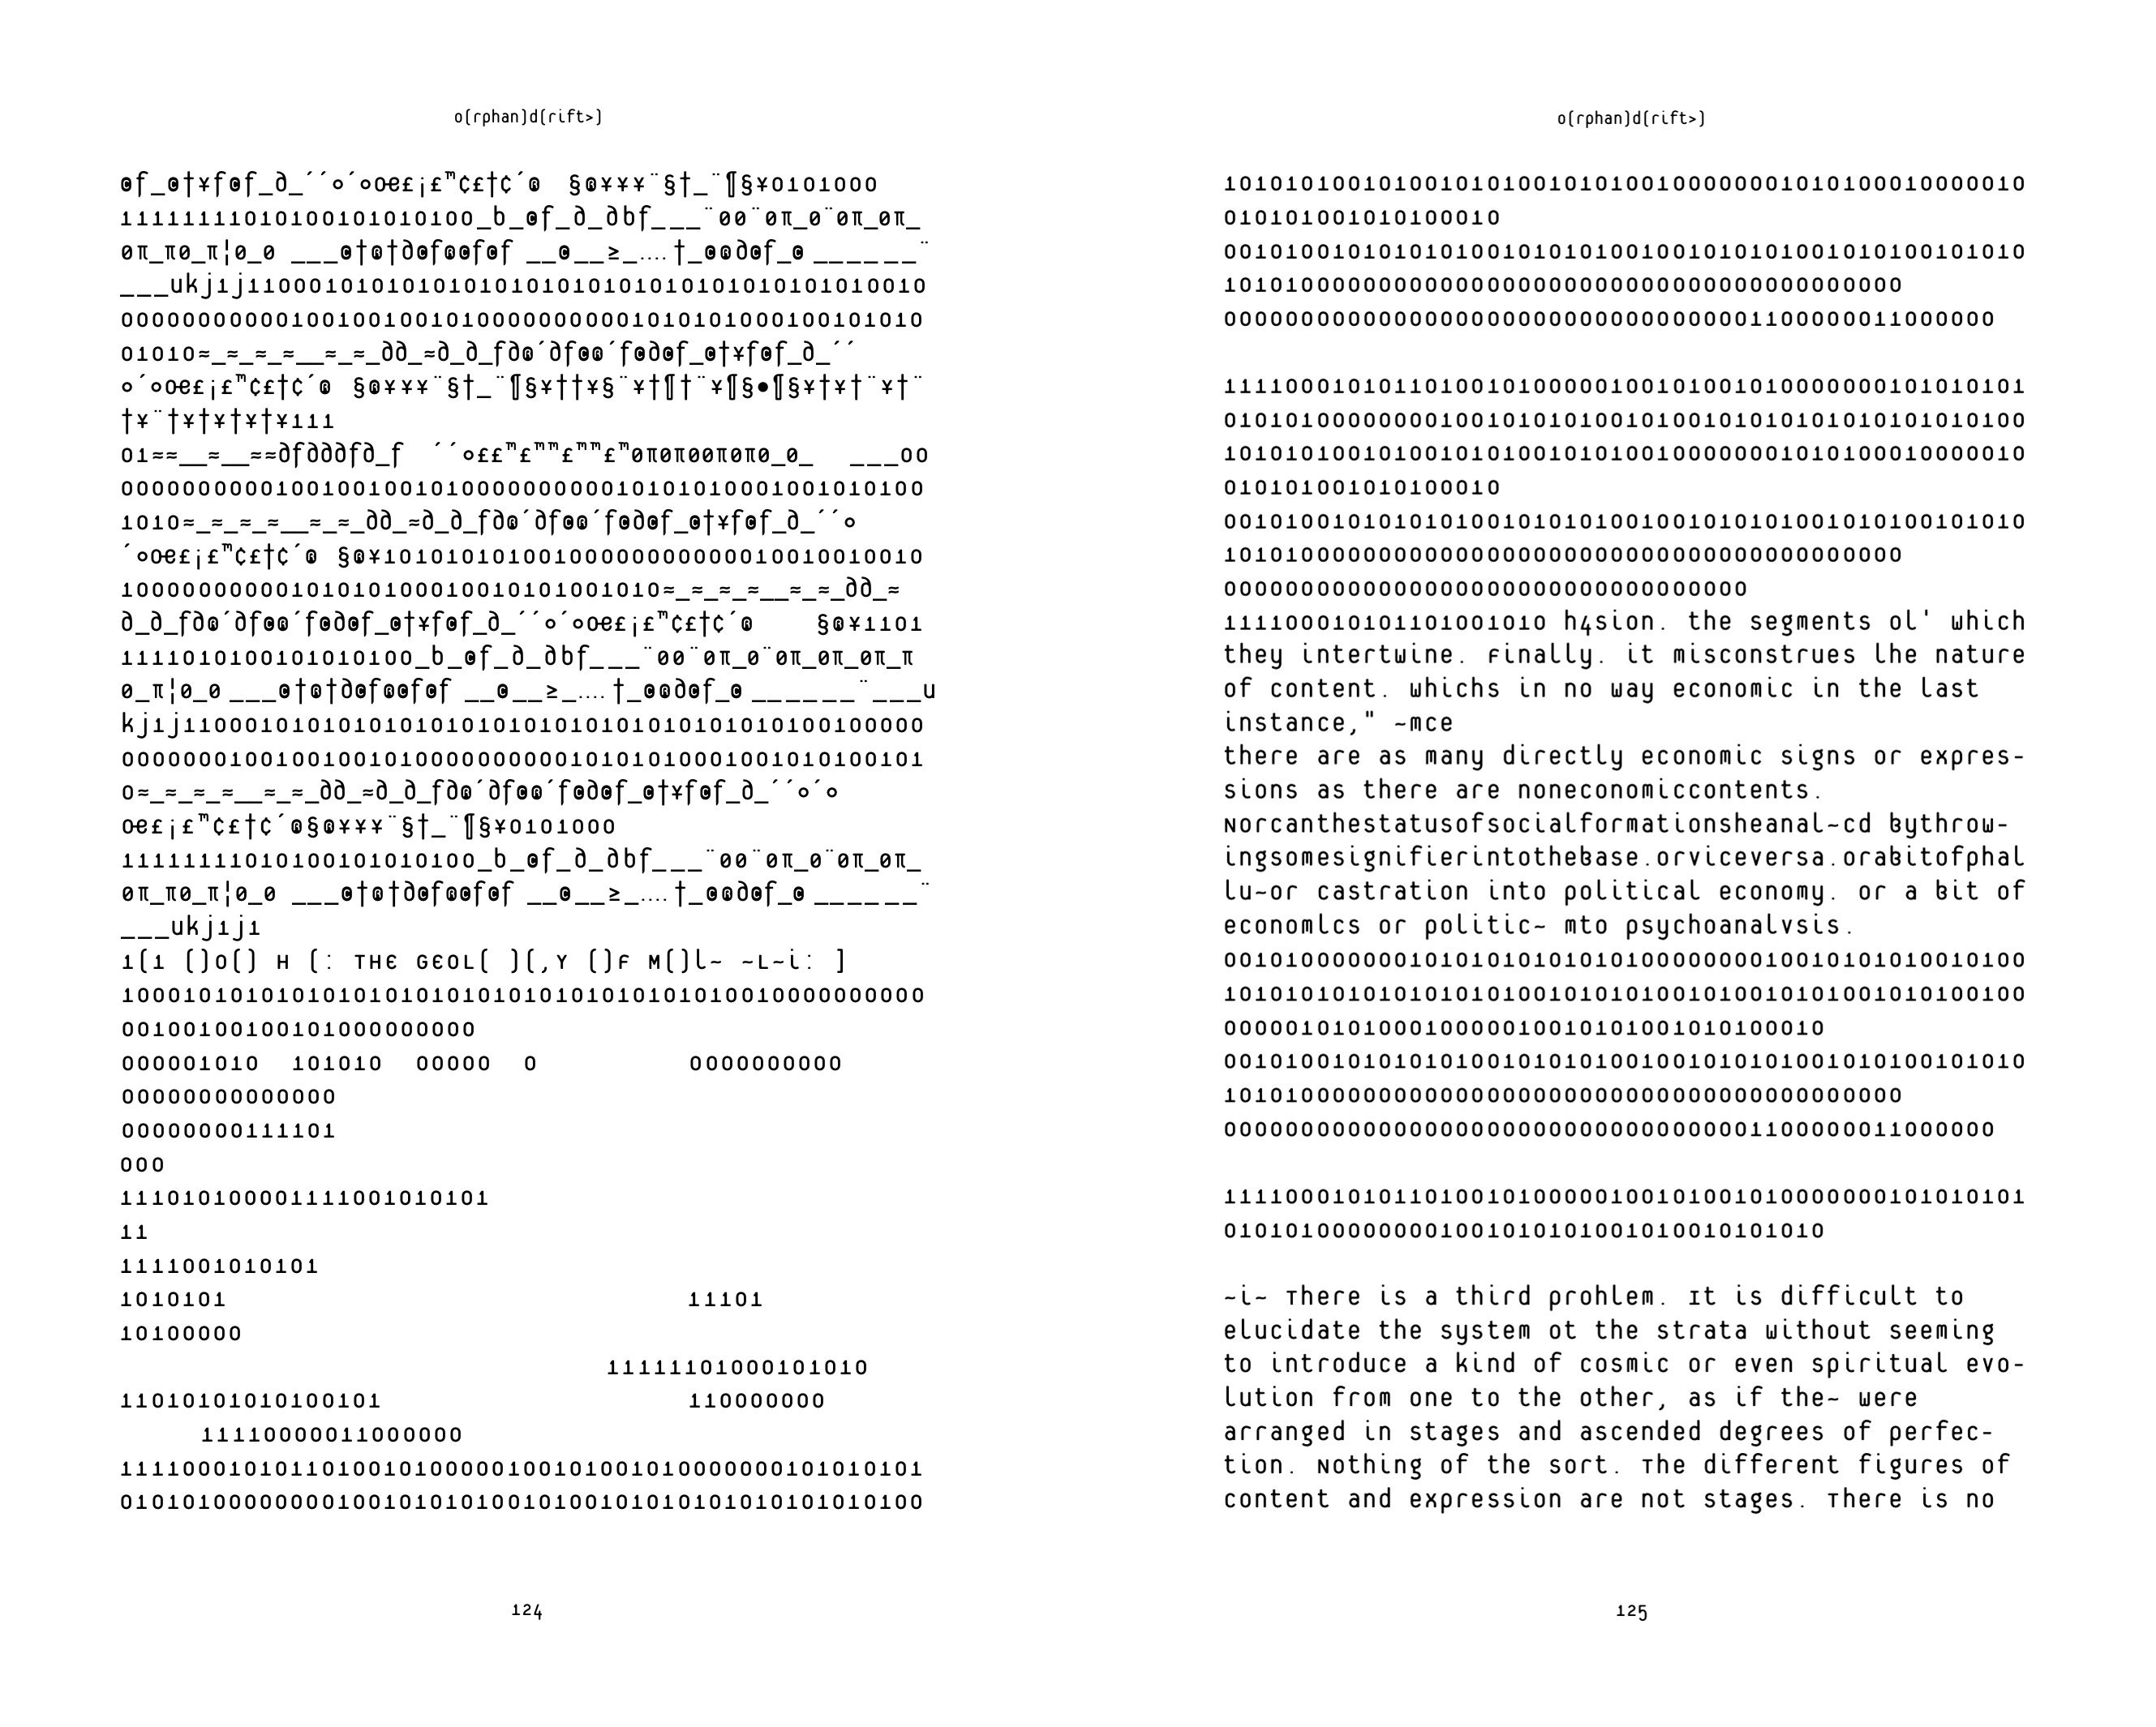
Fig. 1. Double page spread (pp. 124-5) of Cyberpositive

Cyberpositive is therefore a difficult read, partly because of this content, but also because of the particular style in which it is written. Indeed, the science of pattern recognition rather than any kind of interpretation seems most appropriate when engaging with it. The book is partly written in code or, at any rate, in a non-typical syntax – a kind of stuttering and stammering of the keyboard (indeed, some pages are made up of just 0s and 1s) (Fig. 1 is an indicative example of a double page spread). It reads as if written by the very machines and artificial intelligence systems it predicts which, following the philosopher Nick Land (one of the contributors to the book) and his idea of temporal feedback loops, it might well be (as Land remarks in another essay: ‘How would it feel to be smuggled back out of the future in order to subvert its antecedent conditions? To be a cyberguerilla, hidden in human camouflage so advanced that even one’s software was part of the disguise? Exactly like this?’ (2011: 318). Cyberpositive also contains words from other languages, actual and invented (it can read like Antonin Artaud’s peyote ‘poetry’ in this last sense), and at times letters are voided – glitches occur – leaving words and sentences incomplete. The book is not, however, non-sensical even though sense – straightforward meaning and narrative – can and does break down. The content is still held within a minimum consistency (let alone its physical covers).
The science fictioning then operates on two levels: of content (the narrative and philosophy) but also form. Indeed, Cyberpositive is both about and of the future it predicts (it is written in 1996 but from the perspective of 2012). It arrives from a different (AI) consciousness, but it is not simply a story about the latter, a representation – in our familiar language – of this Other. Indeed, again, the book seems to be written by the very machines it writes about and, in this sense, it resonates with another experimental sf-theory of the same period: Manuel DeLanda’s War in the Age of Intelligent Machines (1991). Cyberpositive is a future shock in this sense. To follow Land once more it is a fragment of something-yet-to-come smuggled back into our own time in order to engineer its own genesis. The book is about a schizoid – in the sense deployed by Deleuze and Guattari – out of place and out of time, but is also out of place and out of time itself.
This dislocation is evidenced by its look: the font and typesetting, the cover as well as its size (over 400 pages), shape (narrower than a typical novel) and, indeed, whole object feel. To that end, it is useful to note the original context and point of production of the book. As Maggie Roberts of o[rphan] d[rift>] and Delphi Carstens remark at the beginning of their self-reflection: ‘Cyberpositive begins as a text collage to an installation’ (Carstens and Roberts 2012)). Their essay attends to the collaboratively produced nature of the writing, but also its character as feedback loop. It also lists some of the key influences, progenitors and fellow travelers that it samples, describing the book as a ‘psychogeographical drift through the SF imaginary’ (Carstens and Roberts 2012). After the show and book of Cyberpositive, o[rphan] d[rift>] embarked on a series of performances and audio-visual presentations, often with accompanying texts, culminating in the complex ‘Syzygy’ collaboration with the Cybernetic culture research unit (Ccru). Although not within the scope of this article, a ‘reading’ of that event, conducted over five weekends at Beaconsfield Art Gallery in London and involving the manifestation of demons/avatars premised on Ccru’s calendric system, might also be understood as a form of science fictioning. There is something, though, about the materiality of the original book, a throwback to a previous technology that indicates a future one, something about code being written on paper (the book as proto-digital codex). It is, to use a term associated with its authors, a swarm written novel. This sampling of different voices, very much a ‘cut and paste’ construction, produces a very particular kind of text, one that is prescient of today’s writing practices premised as they are on the edit functions of word processors. But this collaboration – or hive-mind – also suggests a stranger, more alien collectivity from which the book seems to have emerged.
Does this perhaps tie into a certain mythos of o[rphan] d[rift>] and their sometime collaborators, the Ccru, a kind of para-academic research laboratory set up by the cultural theorist Sadie Plant and then led by Nick Land after her departure from academia? (Plant, like Land, contributed to Cyberpositive.) A key concept for the Ccru was ‘hyperstition’ defined as both an ‘element of effective culture that makes itself real’ and a ‘fictional quantity functional as a time-traveling device’ (Ccru a). The Ccru text, ‘Lemurian Time War’, identified Burroughs as a key exponent of what it calls ‘hyperstitional practice’:
Diagrams, maps, sets of abstract relations, tactical gambits, are as real in a fiction about a fiction about a fiction as they are encountered raw, but subjecting such semiotic contraband to multiple embeddings allows a traffic in materials for decoding dominant reality that would otherwise be proscribed. Rather than acting as transcendental screens, blocking out contact between itself and the world, the fiction acts as a Chinese box – a container for sorcerous interventions in the world. The frame is both used (for concealment) and broken (the fictions potentiate changes in reality). (Ccru b)
Such a mythos (and with it, the ‘nesting’ of fictions) requires a collective basis in which to operate. It needs to purport to come from some other place/time, as for instance in the Afrofuturist jazz composer and orchestral leader Sun Ra’s claim to being both an extraterrestrial and the descendent of Ancient Egyptian Gods (what he called ‘myth-science’), even if it necessarily emerges from a scene that is located in a real-world space and time. And it needs objects and images as well as words to cohere and successfully maintain its consistency so as to give it traction in the real. In that sense, the compositional techniques of Cyberpositve are actual as well as virtual, concrete as well as abstract.
‘Liquid Lattice’ (2014), a more recent piece of writing and collaboration between o[rphan] d[rift>] and Ccru, also has this fictioning quality. It was published in the third volume of John Russell’s Frozen Tears project, an anthology of texts and fictions that also worked as a performance not least in its particular length (the size of a large ‘door-stop’ air-port novel) but also the variety and density of its contents. On the one hand, ‘Liquid Lattice’ is again sf – in this case moving from an account of Madame Centauri, her tarot pack and a Black Atlantean magic tradition (with segues of the Cthulu mythos) to more recognisably sf landscapes, cityscapes and seascapes, populated by alien and aquatic hominids. It also has the character of a sampled text, written in different styles and with different forms of inscriptions, from type to hand-written, but also including drawings and photos (Fig. 2 is an indicative double page spread). Once again, older analogue technologies are brought into conjunction with newer digital ones. And yet, on the other hand (as with Cyberpositive) it is not exactly a narrative and certainly is not always an easy read. Different words from languages and myth-systems are included as well as mirrored writing which is all but indecipherable. There are also repetitions, the running through of different permutations of the same elements (reminiscent of the I-Ching) that stymies straightforward linear comprehension. The cut-up character of the text prevents meaning but also suggests new meanings, glimpses of another place and time. Is this not the goal of all art? To produce something that is both of you and not of you at the same time? Something that ‘speaks back’ to you from an elsewhere?

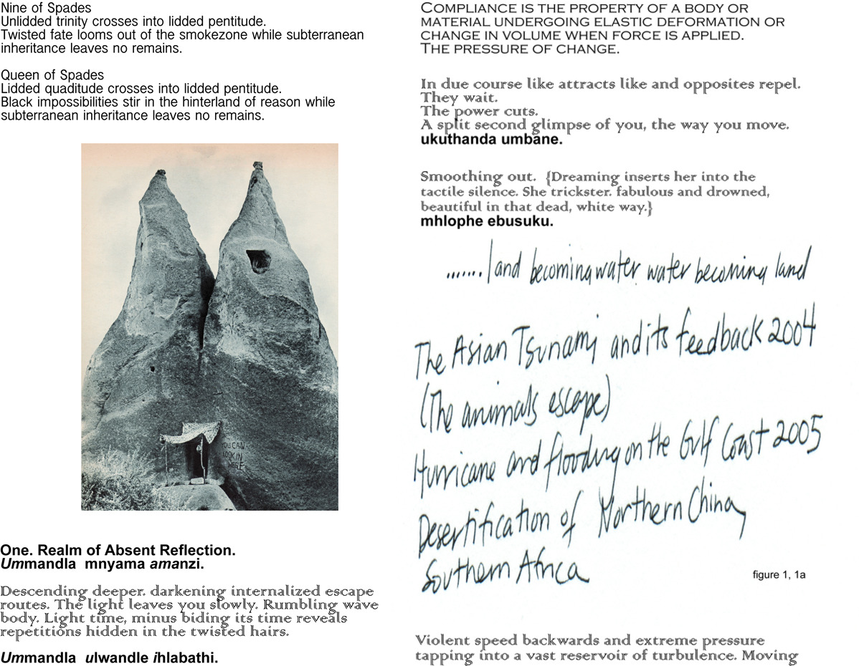
Fig. 2. Double page spread (pp. 10-11) of ‘Liquid Lattice’

If Cyperpositive has a certain urgency, a certain rush, then ‘Liquid Lattice’ is more hallucinatory. The drug references are inescapable: both read, to use Plant’s phrase, as ‘writing on drugs’ (Plant 1999). Again, they are both about and from a different space-time. But in their very existence as objects, in their textual density as print, they are also firmly rooted in the present. This is the temporal paradox this article has been concerned with: how to be in the world but not wholly of that world. It is the move from sf to science fictioning, where ‘to fiction’ is not simply to tell a story about the future or offer up a representation of it but to call it forth. Indeed, there is no longer an attempt to solve the temporal paradox of sf theoretically; instead, it is made manifest – presented as fact – in the here and now.

Works Cited
Carstens, Delphi and Maggie Roberts. 2012. ‘Cyberpositive 2012.’ URL: http://merliquify.com/blog/article s/0rphandrift-cyberpositive/#.VtiiKlyZZ94 (accessed 4 March 2016).
Cybernetic culture research unit (Ccru) a. ‘Hyperstition.’ URL: https://web.archive.org/web/20030204195934/http://ccru.net/syzygy.htm (accessed 4 March 2016).
----- b, ‘Lemurian Time War.’ URL: http://www.ccru.net/archive/burroughs.htm (accessed 4 March 2016).
----- and o[rphan] d[rift>]. 2014. ‘Liquid Lattice.’ In Frozen Tears, Volume 3: Gay Prophecy of the Demonically Social. Ed. John Russell. Birmingham: Article Press, pp. 173-203.
Deleuze, Gilles and Fèlix Guattari. 1994. What is Philosophy? Trans. Hugh Tomlinson and Graham Burchell. London: Verso.
Jameson, Fredric. 2005. Archaeologies of the Future. London: Verso.
Land, Nick. 2011. ‘Circuitries.’ In Fanged Noumena: Collected Writings 1987-2007. Eds.
Robin Mackay and Ray Brassier. Falmouth: Urbanomic/New York: Sequence, pp. 441-60.
Meillassoux, Quentin. 2008. After Finitude: An Essay on the Necessity of Contingency. Trans. Ray Brassier. London: Continuum.
----- 2011. ‘Metaphysics and Extro-Science Fiction.’ In Speculative Solution. Ed. Robin Mackay. Falmouth: Urbanomic, pp. 24-60.
o[rphan] d[rift>]. 2012 (1996). Cyberpositive. London: Cabinet.
O’Sullivan, Simon. 2012. On the Production of Subjectivity: Five Diagrams of the Finite-Infinite Relation. Basingstoke: Palgrave Macmillan.
----- 2016. ‘‘Myth-Science as Residual Culture and Magical Thinking.’ Postmedievalisms (forthcoming)
Plant, Sadie. 1999. Writing on Drugs. London: Faber and Faber.
Roberts, Maggie. ‘Orphan Drift Archive’. URL:
http://merliquify.com/collaborations/0D-phases.php (accessed 4 March 2016).
Simondon, Gilbert. 2011. ‘On the Mode of Existence of Technical Objects.’ Trans. Nandita Mellamphy et al. Deleuze Studies 5.3: 407-24.
Williams, Raymond. 1978. ‘Utopia and Science Fiction.’ Science Fiction Studies 5.3: 203-14.
----- 1980. Problems in Materialism and Culture: Selected Essays. London: Verso.
----- 1988. ‘Science Fiction.’ Science Fiction Studies 15.3: 356-60.

Endnotes ? Although it is worth noting the possibility within this genre (and sf more generally) of the deployment of more residual cultures that offer an alternative or even an opposition to the dominant. This is especially the case with post-apocalyptic fictions as, for example, in Starhawk’s The Fifth Sacred Thing (1993) – or, more pertinent in relation to the arguments I develop in this article around formal experimentation – Russell Hoban’s Riddly Walker (1980). I attend further to the latter in my article ‘Myth-Science as Residual Culture and Magical Thinking’.
In terms of the history of sf one might draw attention to the formal experiments of the ‘New Wave’ of the 1960s and 70s, not least of J. G. Ballard and Samuel R. Delany (and the way in which both of these looked to Burroughs) as opposed to the prior tradition of ‘Hard SF’ that focused on extrapolating science – and which is still present in the post New Wave movement of ‘Cyberpunk’ which also (generally speaking) holds its fictions with recogniseable narrative form.
o[rphan] d[rift>] describe themselves as ‘a collaborative artist’; first actualized in London in 1994 by Maggie Roberts, Suzanne Karakashian, Ranu Mukherjee, and Erle Stenberg, they were especially active in the following decade. Although predominantly visual artists, the collective also involved sound designers, ‘concept engineers’ and media activists and collaborated with many other individuals predominantly on temporary and site-specific works. During this decade they were especially known for their immersive and visually complex audio-visual works which used sampled and re-mixed film and sound as well as collage, print and text (‘treating information as matter and the image as a unit of contagion’). Much of the work explored what they called the ‘mimetic patterns of desire, production and consumption’, particularly as these were manifest at the time with event of digital imaging and sampling technology, as well as in the birth of the web (and, ultimately, ubiquitous computation). A further key aspect of o[rphan] d[rift>] was its function ‘as an experiment with artistic subjectivity’, ‘operating collectively as a singular artist which subsumed the individual artistic identities of its core members’ (as evidenced, for example, in the authorship of Cyberpositive). The group made extensive contributions from 1994-2004 in the social arenas around contemporary art, underground music and cyber-feminism/post-structural philosophy. o[rphan] d[rift>] exhibited widely including at the Tate Modern, Hayward and Cabinet Galleries in London, contributed cybervisuals to the set of Stephen Spielberg’s AI and Minority Report and Leftfield and Nine Inch Nails world tours and participated in 10 years of international Video art and AV Electronica art events in Norway, Germany, Canada, UK, South Africa and USA (the above quotes – and general history – have been extracted from the 0D archive on Maggie Robert’s website).

