Making things to make sense of things:
DiY as research subject and practice

KAT JUNGNICKEL
In press
The Routledge Companion to Media Studies and Digital Humanities
edited by Jentery Sayers

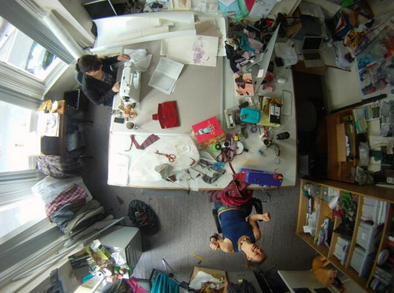

This image comes from a time-lapse camera fixed to the ceiling of my office that took photos every 10 seconds every day for the last few weeks of a research project about cycling, gender, and citizenship. This frame captures a particular event. After many attempts, I had successfully sewn a buttonhole in a tricky position near the waistband of a Victorian convertible cycling skirt. But it was not just a buttonhole. In fact there was no button involved. Instead, it was a critical component in an intricately designed technological system concealed in the framework of the costume. The mechanism comprised a hidden pulley system, stitched channels, long waxed cords, and weights that enabled the wearer to not only gather the front and back of the skirt up to a desired length (out of the danger of the bicycle wheels) but also quickly reverse this action when required. The purpose of which was to enable the wearing to adapt her costume at will depending on her mobility requirements, in particular regard to her cycling practices. I was following the step-by-step instructions of the inventor who had patented the complexly engineered costume in 1895. This buttonhole was the last component to be completed prior to installing the cords and testing it out.

Why was I doing this? Why was I making such a mess in my sociology office? Why was I sewing my research? I was working on a project called “Freedom of Movement: the bike, bloomer and female cyclist in late C19th Britain” (otherwise known as Bikes & Bloomers) about Victorian cycle wear. I’d been researching contemporary cycling cultures and noted how often respondents, unprovoked, talked about what they wore to cycle and how certain clothing choices elicited welcome and sometimes less welcome responses from others. I quickly learnt that cycle wear mattered. Brief archival research indicated this was not a new concern so I started to look historically for more in-depth answers to why cycle wear still matters.

In the process I became fascinated by patents lodged by inventive women for new forms of cycle wear to address social, ideological, and physical issues faced by early adopters of cycling, a new mobility technology of the period. For many enthusiastic women cyclists, their clothing, along with society’s ideas of how, where, and in what ways women could move in public space, inhibited their freedom of movement. (See Jungnickel (2015) for more discussion on the social, cultural and political context in which middle and upper class women were learning to cycle and how they shaped and were in turn shaped by Victorian society). Some responded to these constraints by designing convertible garments. While there is evidence that some patented designs were commercialized and distributed across the UK, I have yet to find any existing artifacts of this nature in UK museums or galleries and little has been written about this inventive cultural practice (with the exception of Kahn 2000; Helvenston Gray and Peteu 2005; Peteu and Helvenston Gray 2009). In addition to exploring if links could be made between the advent of cycling at the turn of last century and the politics of cycle wear today, I set out to answer the following question: What might making these costumes by hand reveal that reading and analysing media in the from of a patent could not?

To answer these questions I collaborated with a pattern cutter, weaver and artist to make a collection of convertible Victorian women’s costumes inspired by UK patents lodged from 1895 to 1899. Together we transformed these inventive women’s ideas into three-dimensional artefacts and conducted an ethnography of making along the way. In total, 28 garments assembling five costumes were handmade by the research team (myself and one RA with another joining us for the last month) in my sociology office over a nine-month period.

This chapter is about making as research or, more specifically, making things to make sense of things. From a practice-based research perspective I examine the idea of media as something the researcher not only studies but also makes in the process of doing research. This chapter is also about DIY (Do-IT-Yourself) as research subject and practice. I bring to this discussion how learnings from DiY and also DIT (Do-IT-Together) technocultures can be brought to bear on critical research methods, specifically the desire to engage materially with media, learn from doing, and, in the process, render public the visible and tangible mess, mistakes, and tangential happenings.
The argument that follows outlines the theoretical and methodological context in which making as a research practice is positioned. I specifically look to mobilities research and science and technology studies (STS), where there is a burgeoning interest in experimental sensory and material approaches. Throughout I discuss how making things to make sense of things presents opportunities for new ways of getting inside mobile, messy, and multiple social worlds.

The Politics of (Media) Making
Social science researchers make things in the process of making knowledge—notes, interviews, photos, drawings, arguments, charts, graphs, and presentations, amongst others. Yet, for a discipline engaged with a spectrum of inventive methods on many fascinating topics, the nature of knowledge objects and outputs predominantly takes the form of text and talk, which is surprisingly curtailed in terms of creativity, materiality, and form. While the senses are often central to an understanding of social processes, rarely do they feature in how we tell about society. As Guggenheim (2014) has argued, this marks sociology out in particular in comparison to life and other natural sciences:

When we compare this situation with other disciplines, such as biology, astronomy or chemistry, where all kinds of technologies are used to represent the world, from drawing, to computer models, from complex machines visualizing things very big and very small; to transform smells or heat into visual traces, it becomes apparent how unusual this situation is. (2014:346)

‘Stituations’ are formed of disciplinary frameworks where specific kinds of knowledge practices are shaped, expected and legitimized. They become normalized practice, mundane in their ubiquity and as result hard to see. Yet situations are never fixed. They can change, and we can change, especially when we see our cultural norms in the context of others.

While the dominance of text in the social sciences remains an issue, this chapter is set against a growing interest in attending to less fixed and easily representable and more ambiguous and sensory socio-mobile constructions of everyday life (Spinney 2011; Büscher et. al., 2011; Jungnickel and Aldred 2013). In the past, scholarship in the field of mobilities in particular has been criticised for a tendency to tidy up and stabilise mobile subjects in order to study them. This in part has spurred the growth of “mobile methods”, which Büscher et. al., explain are an attempt “to move with, and to be moved by, the fleeting, distributed, multiple, non-causal, sensory, emotional and kinaesthetic” (2011: 2). Video is increasingly at the forefront of a desire for researchers to “be there” even when they are not (Spinney 2011). On its most basic level, this is an attempt to stay mobile in a mobile fieldsite. For Spinney, the use of video is also “a tool to extend sensory vocabularies” (2011: 117). Aldred and I (2013) have looked at cyclists’ “sensory strategies” and the ways in which assemblies of clothing and associated technologies such as headphones can be used to inhibit or amplify elements of the environment. This body of literature opens up new terrain for thinking about the intersection of mobilities, technologies, and bodies.

While mobilities scholars have been at the forefront of these methods, given the dynamism of their subject of study, similar moves are evident more broadly in the social sciences and especially in STS (Law 2004; Hine 2007; Back 2012; Back and Puwar 2012; Lury and Wakeford 2012; Orton-Johnson and Prior 2013, Guggenheim 2014). For many scholars this entails bringing the researcher into a closer, more intimate and responsive entanglement with research subjects. It is a move that both evokes and provokes the social. Back, for instance, asks how we might “account for the social world without assassinating the life contained within it” (2012: 21). This is the premise of Back and Puwar’s (2102) “Live Sociology”, capable of responding in creative and spontaneous ways to rich, complex, multi-sensory, and multi-dimensional worlds. Critically, for this chapter I am struck by how Back emphasizes that this is not just about interpreting things into words, given sometimes “what remains unspoken can be of even greater significance” (Back 2012: 28). Instead, it involves developing “attentiveness to the multiple registers of life” and considering other ways in which the social can be explored, articulated, and known (2012: 29).

Another valuable contribution in this field is Lury and Wakeford’s work on inventive methods. In an edited collection of 17 chapters on different “devices”. they explain how inventive methods “introduce answerability into a problem” and how they do not “leave that problem untouched” (2012: 3). Critically, for this chapter, the kinds of inventiveness enabled through these methods “can never be known in advance” (2012:7) or as Fuller and Goriunova explain, “they are something that happens that make something happen” (2012:168). Mess has also been a theme of much methodological discussion in the social sciences (Law 2004; Hine 2007). Law explores the idea of moving closer to the messy nature of social worlds when he argues that conventional sociological methods can serve to create realities that are “independent, prior, singular, definite and passive”, all of which suggest realities are separate from researchers (2004:147). Although these restrictions have their place, he says we should embrace and draw from mess in order to realise other modes of description and unlock the potential for expressing different versions of the world.

This chapter continues the move towards recognizing less conventional knowledge practices and the production of alternate representations. However, it also shifts attention from mess and methods to making. In doing so concern lies with the entire process. Making is a means of doing research. In the next two sections I provide examples of some of the challenges and opportunities of this approach in my practice.

DIY as Subject, Method, and Practice
My interest in open source technology communities provoked my initial forays into hacking, tinkering, and critical making practice. During my PhD I ethnographically studied the largest volunteer WiFi network group in Australia. In this group, individuals were collectively building a customized wireless network across the largely suburban city of Adelaide, capital of South Australia, by linking handmade antennas, many of which were located in backyards and on sheds. Rather than simply adding content to the internet, members were constructing the very architecture of the internet from the ground up, or in this case from the backyard out. They were making what they called “ournet not the internet”. Their practices were imbued by a DIY ethic but they were not doing it alone—they were Doing-It-Together.

For the purposes of the study I defined DIY as a hands-on physical engagement with a diverse set of materials and improvised methods for the purpose of creating or repairing something usually for not-for-profit use outside the times and spaces of traditional technology innovation. I defined DIT as an approach that marries a collaborative social engagement with a willingness to tinker predicated on an understanding of technology as open, malleable, and participatory (Jungnickel 2014).

While I was doing WiFi research, I stumbled into another grassroots technology culture, in the form of a freakbike club, which exposed me to yet another way of engaging with open source practices. Like WiFi makers, freakbikers customise and adapt discarded, freely available or cheaply purchased materials, re-inscribing them with new meanings and re-imagined possibilities of use. Freakbikers hand build bicycles from rubbish and discarded materials that push the boundaries of conventional cycling and the nature of the bike (Jungnickel 2013). My engagement with freakbikers identified me as a maker of technology, interested and able to get inside the ‘black box’, which afforded me entry into a particular way of expressing engagement with materials and practices. Both groups rendered their making practice visible, invited people into a “black boxed” technology (albeit in different ways) and encouraged them to imagine how things might be “otherwise” (Bijker and Law 1992). Here, my mundane bicycle was as much an ethnographic tool as a vehicle of transportation.

Although very different, I was struck by similar elements of practice, which informed the way in which I made sociological arguments about technology makers (Jungnickel 2010). Respondents appeared unfazed by uncertainty and mistakes, and tangents from experimental activities were not considered accidents to be erased. Instead, they were built into systems, considered critical to practice and representational storytelling. Making was a vehicle for expected and unexpected happenings that resisted being contained neatly as topic, method, or process. Members made resourceful technologies capable of adapting to changing conditions as a result of, not in spite of, ambiguities. I drew inspiration from this practice of engaging in uncertainty and sharing haphazard improvised activities. I have since attempted to “remain faithful to experiences of mess” (Hine 2007: 12) by exposing vulnerable ideas and seeking responses and public engagement with multiple iterations of research in many forms.

Similarly, Bikes & Bloomers is fundamentally a project about DIY and DIT socio-technical cultures. At one level, the women who patented their new cycling costumes did so because appropriate cycle wear did not exist. They had to do it themselves. Yet, they too did not do it alone. Although legal mechanisms attribute knowledge to a single author, the reality was more likely to resemble a messy collective of shared technologies and skills, circulating ideas, and social support. Making was at the core of their actions. They were engaged in the making of costumes for safer, more comfortable cycling and also making new forms of mobile gendered citizenship. Their actions were complicit in carving out new political and ideological ways in which newly mobile women could move in and through public space. Therefore it is a story as much about the changing nature of mobile citizenship as it is about clothing inventions (Jungnickel 2015). Much like my point earlier about the bicycle as a dual tool, patents are simultaneously rich archival data, ethnographic tools and political devices.

Patents as Media in the Making
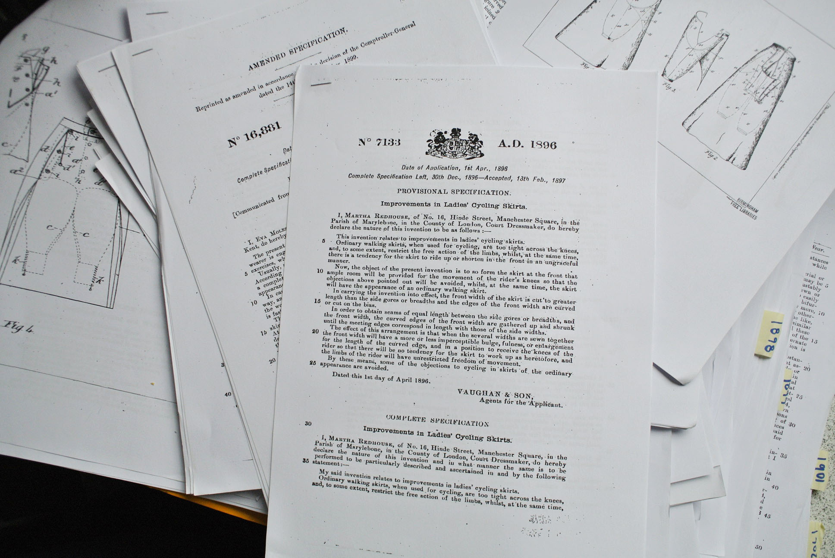

Patents are classic “immutable mobiles” in that they are easily and infinitely reproducible, can travel, recruit people and enact power (Latour and Woolgar 1979). In addition to being valuable receptacles of archival data, they are also fascinating design objects. Inventors describe in detail the problem they attempt to solve, illustrating the process in text and annotated line drawings, and in doing so provide a glimpse into the socio-cultural context of the time. Yet, patents also conceal as much as they reveal. In their flattened form they give the appearance of an incontrovertible list of claims. Their formulaic nature is deliberately designed to make complex knowledge appear ordered, neat, and as a result compellingly persuasive. In classic STS language, patents are “black boxed”. STS scholars are particularly sensitive to artefacts and systems that look convincingly smooth, so much so that from the outside they become easy to accept without question. They become easy to overlook and underexamine. Many argue that, once paths of innovation and use become established, it is harder to see or change systems than when they are fresh and new; it is not long before they appear as if they have always been there (Callon 1986; Latour 1999; Graham and Thrift 2007). Graham and Thrift write about how systems can seem “characterized by perfect order, completeness, immanence and internal homogeneity rather than leaky, partial and heterogeneous entities” (2007: 10).

Making, then, can be viewed as an interruptive practice that shifts these conventional registers. From a making perspective, historical patents are transformed from a smooth, closed, and legally framed text into an invitation for ‘embodied entanglement’ (Barad 2007) and three-dimensional argument. They are direct incitements to make and, in doing so, bring to light broader, messier, and complex (inter)connections. Making provides a means of exploring through the possibilities of interpretation the intentions of the original designer, of revealing new entry points into research and eliciting feedback and interaction with diverse audiences. As a maker, I do not claim to replicate the exact patented design, but rather a version. In making public my work in progress I use it both as a tool for my own meaning making and for engagement with others.

To make from a patent involves interpreting the inventors’ instructions and paying close attention to the labour involved, including time to accomplish small tasks such as making buttonholes that enabled larger systems to operate. It invites a close consideration of materials, technologies, skills, and bodies in the making of knowledge, such as mine as the maker but also the communities of women in the 1890s who shared skills, devices (such as sewing machines), fabrics, patterns, and support. This reflexive ethnographic approach draws on Star’s (1995) techno-feminist work in The Cultures of Computing, where she considers the computer in relation to a richer, more complex and present politic of the body.

Right now, typing this my neck aches and I am curled in an uncomfortable position. I try to think about my fingertips and the chips inside this Macintosh as a seamless ‘web of computing’ to use Kling and Scacchi’s classic phrase (1982). But chips make me think of the eyesight of women in Singapore and Korea, going blind during the process of crafting the fiddly little wires; of ‘clean rooms’ I have visited in Silicon Valley and the Netherlands, where people dressed like astronauts etch bits of silicon and fabricate complex sandwiches of information and logic. I think of the silence of my European ancestors who wore Chinese embroidery, marveling at its intricate complexity, the near-impossible stitches woven over a lifetime with the eyesight of another generation of Asian women. I think, I want my body to include these experiences (1995: 2-3).

Star’s powerful writing provokes us to look into, to think further or differently about, something that appears deceitfully smooth on the surface. Her work invites us, in the process of making, to claim our own positionalities and others in relation to the black box, to get beneath the surface to see how it is made, who is and is not involved, and how it came about. She reminds us about the fascinating aspects of the mundane and ‘boring’ (Star 1999). The ethnography of making, captured in time-lapse photos, reveals through the mundane practice of sewing a buttonhole an emotional and physical entanglement in and with the research. In the outstretched body, the relieved face in respite from concentration, the raised arms, the labour of making is rendered visible and visceral. These close encounters with research bring the often ignored or hidden into rich, embodied, affectual present.

Imagining Different Futures Through Victorian Women’s Convertible Cycle Wear
The cycling costume with the hidden pulley system hidden was patented by Alice Louisa Bygrave on 6 December 1895. Her aim was to improve conventional skirts, to allow women to occupy dual identities – reputable lady and cyclist – at a time when the latter was socially difficult for some women. To make these garments we collaborated with a team of talented people, and these interactions all helped to add texture and nuance to the project. For instance, the pattern cutter worked from patents and the design briefs we provided from our archival research. Together we embarked upon a process of multi-dimensional dynamic translations; from drawings, photos and text into mock-up toiles and then into pattern pieces. So often the act of research involves the taking apart of something – gaining entry into a smooth, closed black-boxed system. Here, we were engaged in the act of piecing things together. Equipped with patterns we constructed various iterations, sewing scaled practice garments which slowly lead to full-sized pieces. We tried on each one on at various stages, using our bodies to make sense of them and make them work, making mistakes, mending, adjusting and experimenting. This process revealed many challenges and surprises, such as the demanding presence of small seemingly inconsequential things such as buttonholes that were not only critical to the successful workings of the system but also important socio-cultural storytellers.

Stories about the future are often told in the authoritative fields of science and engineering by what Star has called ‘heroes, big men, important organisations or major projects’ (1991:12). Feminist STS scholars have long drawn attention to the lesser-known roles, particularly of women, behind the scenes of technological systems (Schwartz Cowan 1983; Star 1999; Kahn 2000; Wajcman 2004). As Wajcman writes: ‘[T]heir absence is as telling as the presence of some other actors, and even a condition of that presence’ (2004:41). This scholarship draws attention to marginalised voices and perspectives and in the process raises questions about men’s monopoly over the history of technology. In the past, few women’s voices have been heard because their contributions have either been rendered invisible or not recognised as important, with many technological inventions appearing to come from a single (male) author, reinforcing the ideal of an independent inventor. In reality, it was more likely to have been groups of people who worked on similar inventions at the same time.

As Schwartz-Cowan points out, it is not just some inventors we hear little about. It is also certain kinds of technologies such as the baby bottle, which she argues ‘transformed a fundamental human experience for vast numbers of infants and mothers’ and ‘yet it finds no place in our histories of technology’ (1983:52). In a similar vein, Kahn argues: Studies in the history of technology exhibit many biases, but the two most significant are the tendency to mythologize supposed “heroes of invention,” “macroinventions,” and large discrete inventions, and the failure to pay systematic attention to the relationship between women and technology (2000:191). Reflecting on this argument, it is possible to consider that a wider range of inventors would tell different stories about modernity, mobility and the body.

Overall, this form of making and entangling through design histories surfaces new and different ways of understanding mobility, gender relations and costume design. It is an attempt to (re)place women’s stories in rich, messy and dynamic socio-technical timelines. The project also builds on the work by design and material cultural scholars on the history of domestic dressmaking, which has long being undervalued and overlooked. As Burman writes: ‘The ordinariness and domesticity of home dressmaking would seem to have contributed to its invisibility and the lack of analytical purchase on the part of historians in related fields’ (1999:3). Convertible cycle wear can be considered an extreme version of this in that it was deliberately designed to resist detection. With a focus on inventive women’s clothing designs the research aims to give voice to less triumphal heroic narratives in cycling history, which has more often been dominated by stories of ‘young men of means and nerve’ who would showcase their masculine verve in public (Bijker 1997:41). Fundamentally, it is a means of bringing to the surface different ways of understanding mobility and the design of mobile citizens.

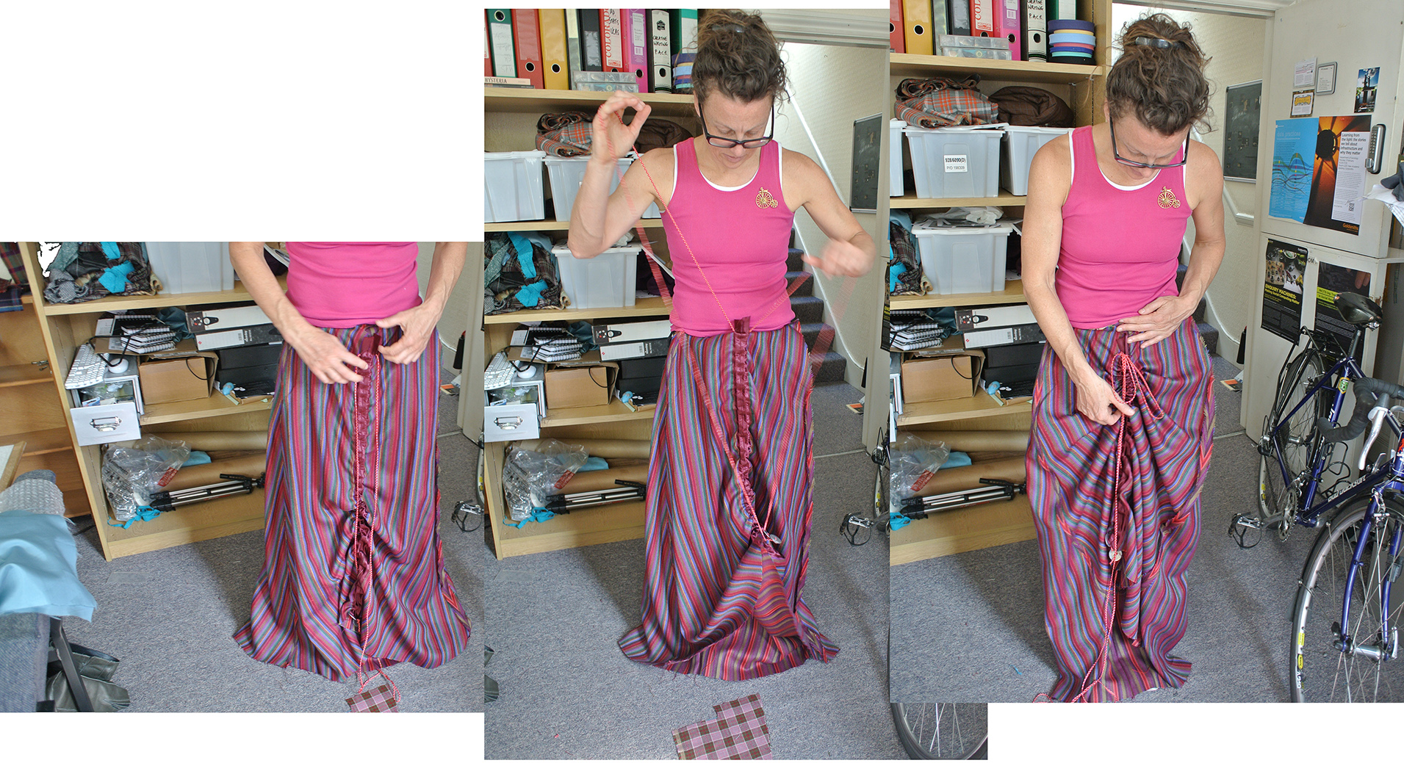

Getting inside Mobile, Messy, and Multiple Social Worlds
So, what does sewing bring to research practice? I have responded to this question through a discussion of Bikes & Bloomers: a multi-faceted research project that interweaves new and unusual making perspectives, bringing them to bear on qualitative studies of mobility, gender, and citizenship. I also drew on learnings from DIY and DIT technology cultures that appeared to delight in instability and render their mistakes and tangents public rather than hiding or tidying them up. This is a cultural practice through which individuals are encouraged to experiment, to craft skills through trial and error and in the process build resilient and creative systems and artefacts that adapt to changing conditions. Throughout I have argued that a critical practice involving making provides the means for researchers to get closer to, and in this case into, a subject. Here, we have to make choices, make mess, learn from mistakes, clean up, re-do things, develop skills, and think not only about our subject area but also our own positionalities as we physically engage in the labour of knowledge making.

It is important to re-iterate that I am not arguing for the primacy of making over conventional research practices. Instead, what I have attempted to convey is that making provides an opportunity for broadening existing methods and research skills. For instance one of the advantages of this approach lies in being able to moving in and out of research, zooming up close and then stepping back and walk around it. Shifts like this are discussed at length in many classic methods texts. In sociology, this is often told in reference to C. Wright Mill’s ‘Sociological Imagination’ (1970), which reminds us that the micro personal issues are always valuable as they can be linked to larger historical and social contexts. The history of Victorian women’s convertible cycle wear is a fascinating and largely under explored example of this. On one hand these are intimate personal stories of adaptation to restrictions posed on women who desired to cycle yet they also speak of much larger socio-cultural, political and ideological issues. Some of the inventions patented by women cyclists afford small incremental changes while others promise radical transformations, and yet they share a common theme – all are deliberately hidden from view. The fact that cyclists could wear these garments undetected is a symbol of its success but has also meant that little is known of this inventive culture in British cycling histories.

Returning to the buttonhole image that opened the paper, it is clear that I was wrestling with the costume. The image may capture the moment of success, but in doing so it renders visible, through their absence, the hours of trial and error that lead to this point. I had been hunched over the machine, ignoring all kinds of appropriate computer postures, sewing my way through a problem—and it was not a problem on the page; it only emerged in practice. I had not thought much about buttonholes prior to the project. (I certainly did not anticipate writing a chapter on them). And if I had, it was in a functional context: buttonholes (with buttons) fasten things. Interestingly, the term also means to “attract the attention of and detain (someone) in conversation, typically against their will” (Oxford Dictionary 2015). Both definitions are concerned with closure. Yet, within the context of making patented convertible cycling skirts, buttonholes were transformed into technologies for opening up new landscapes of possibility for the women who wore the cycling costumes, and for me as a researcher in understanding this cultural practice and deepening my own practice.

In this context, this mundane and highly domestic device (and practice)—the buttonhole—was transformed into a complex and challenging component of a hidden technological system. The buttonholing image is part triumphant, part relief. I had finally worked it out. I could move on. But in the process I gained deeper insight into the research and the women inventors. The value of these small examples lies in how they render visible larger systems and practices, such as the politics of the body, socio-technical cultures, hidden infrastructures, and skills, technologies, and labour involved. It is a valuable reminder that what might appear to be a simple and boring, such as a buttonhole on a patent, might in fact, be boring and also something else entirely.

Social science’s continued impact and relevance relies not only on what it says but also how it tells stories. This chapter contributes to a growing interest in alternative practices, objects of study, and sites and tools for describing and engaging social worlds. This is an exciting time for our disciplines. While there is lots of discussion about new exciting methods, actually doing this kind of research occupies the fringes of the sociological imagination because making anything other than talk and text is not yet central to practice. Researchers are pressured to resist tidying up mess and flattening dynamic mobile social worlds, and yet many conventional academic mechanisms directly reflect and shape particular practices. How do we slowly change this? Maybe one small buttonhole at a time.

Acknowledgements
Bikes & Bloomers is part of the ‘Transmissions and Entanglements: Making, curating and representing knowledge’ project supported by an Economic and Social Research Council Knowledge Exchange grant (ES/K008048/1).

References
Back, L. (2012). Live Sociology: social research and its futures, In Back, L and N, Puwar. (eds) Live Methods. Oxford: Blackwell Publishing, pp. 18-39
Barad, K. (2007)Meeting the University Halfway: Quantum Physics and the Entanglement of Matter and Meaning, Duke University Press
Bijker, W. E and J, Law. (1992) Shaping Technology/ Building Society: Studies in Sociotechnical Change, Cambridge MA: MIT Press.
Burman, B. (1999) The Culture of Sewing: Gender, consumption and home dressmaking, London: Berg Publishing
Büscher, M., Urry. J and K, Witchger (eds) (2011) Mobile Methods, UK, USA, Canada: Routledge.
Callon, M (1986). The Sociology of An Actor-Network: The Case of the Electric Vehicle. In Callon, M., Law, J. and Rip, A. Mapping the Dynamics of Science and Technology: Sociology of Science in the Real World. Sheridan House Inc
Fuller, M and O, Goriunova. (2012) Phrase, In: Lury, C and N, Wakeford. (eds) 2012. Inventive Methods: Happenings of the social, London: Routledge. pp. 163-171
Graham, S and N, Thrift. (2007) Out of order: Understanding repair and maintenance, Theory, Culture & Society, 24(1): 1–25.
Guggenheim, M. (2015) The Media of Sociology: Tight or Loose Translations? British Journal of Sociology, 66 (2): 345-372.
Helvenston, Gray, S.H, and Peteu, M. C. (2005) Invention, “the angel of the nineteenth century”: Patents for women’s cycling attire in the nineteenth century. Dress, 32, 27-42.
Hine, C. (2007) Multi-sited Ethnography as a Middle range Methodology for Contemporary STS, Science, Technology & Human Values, 32 (6), pp. 652-671.
Jungnickel, K. Bikes & Bloomers Research website, www.bikesandbloomers.com
Jungnickel, K and R, Aldred (2013) Sensory Strategies: How cyclists mediate their exposure to the urban environment. Mobilities, Published online June 14
Jungnickel, K. (2015) “One needs to every brave to stand all that”: Cycling, rational dress and the struggle for citizenship in late nineteenth century Britain, Geoforum, Special Issue: Geographies of citizenship and everyday (im)mobility.
Jungnickel, K. (2014) DiY WiFi: Re-imagining Connectivity, London and New York: Palgrave Pivot
Jungnickel, K. (2013) Getting There …and Back: How ethnographic commuting (by bicycle) shaped a study of Australian backyard technologists, Qualitative Research, 14: 640-655
Jungnickel, K. (2010) Exhibiting Ethnographic Knowledge: Making sociology about makers of technology. Street Signs, Centre for Urban and Community Research, London: Goldsmiths, pp. 28-31.
Kahn, Z. B. (2000) “Not for Ornament”: Patenting activity by nineteenth-century women inventors, In Journal of Interdisciplinary History 31(2): 159-195.

Knowles, C and P, Sweetman. (eds) (2004) Picturing the Social Landscape: Visual methods and the sociological imagination, London and New York: Routledge
Bruno Latour (1999). Pandora's Hope: Essays on the reality of science studies. Cambridge, Massachusetts: Harvard University Press.
Latour, B and S. Woolgar. (1979) Laboratory Life, The Social Construction of Scientific Facts, London: Sage.
Law, J. 2004. After Method: Mess in Social Science Research, UK: Routledge.
Lury, C and N, Wakeford. (eds) 2012. Inventive Methods: Happenings of the social, London: Routledge.
Mills, C.W. (1974) The Sociological Imagination, Oxford University Press
Orton-Johnson, K and N, Prior. (eds) 2013. Digital Sociology: Critical perspectives. NY: Palgrave.
Peteu, M., C and S, Helvenston Gray (2009) Clothing Invention: Improving the Functionality of Women’s Skirts, 1846-1920, Clothing and Textiles Research Journal, 27 (1) : 46-61
Spinney, J. (2011) ‘A Chance to Catch a Breath: Using mobile video ethnography in cycling research’, Mobilities 6(2): 161-182.
Star, S. L. (1995) (ed) The Cultures of Computing, Oxford: Blackwell Publishers
Star, S, L. (1999) ‘The Ethnography of Infrastructure’, In P, Lyman and N, Wakeford. (eds) Analysing Virtual Societies: New Directions in Methodology, American Behavioural Scientist, 43 (3), pp. 377-391.
Wacjman, J. (2004) TechnoFeminism, Polity Press

